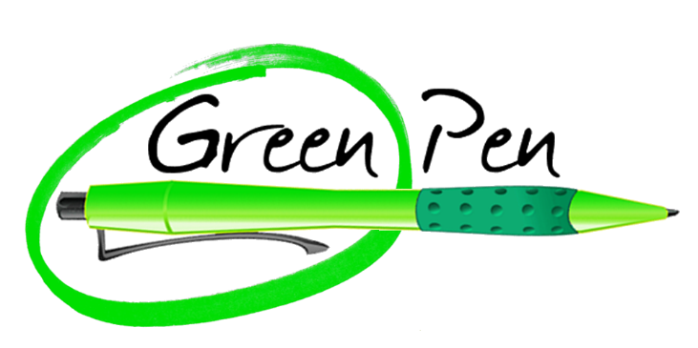

**Positive Points**

In each of the 3 upper semicircles add a brief positive point about your work.

**Improvement**

In each of the 3 lower semicircles add a brief improvement point about your work.