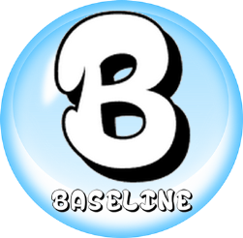

**Title of piece of work:**

State something that went well with your work and something that could be improved. Use either the Green, Amber or Pink set of question below:

**PINK**- What? Why? Why?

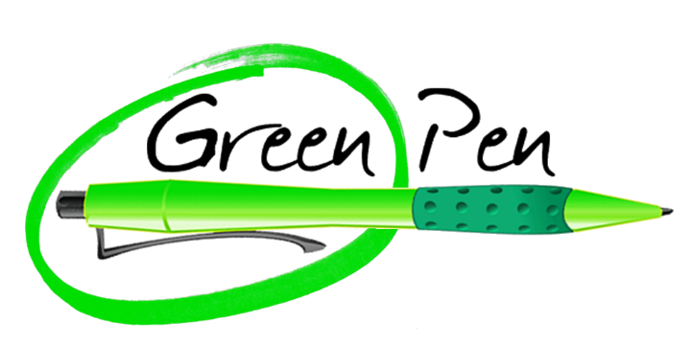

When you have completed the reflection activity tick which improvements you completed

**AMBER**- What? Why?

**GREEN**- What?