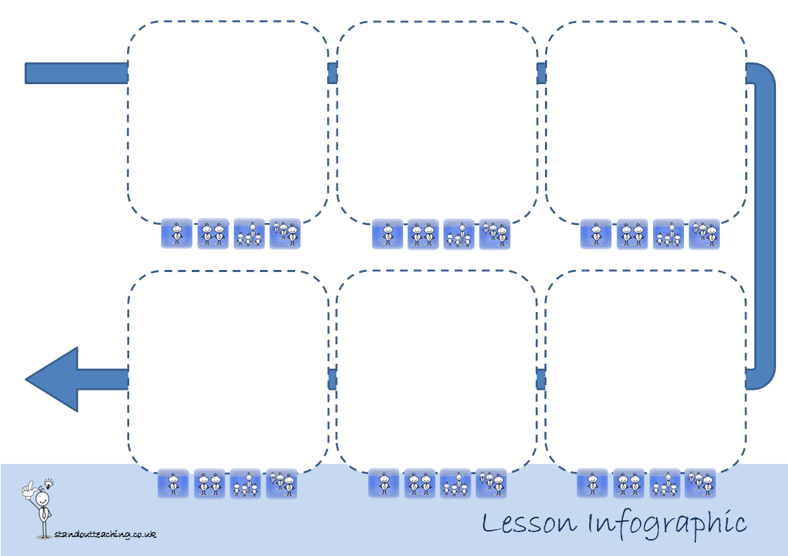

**Lesson**

**Doughnut**