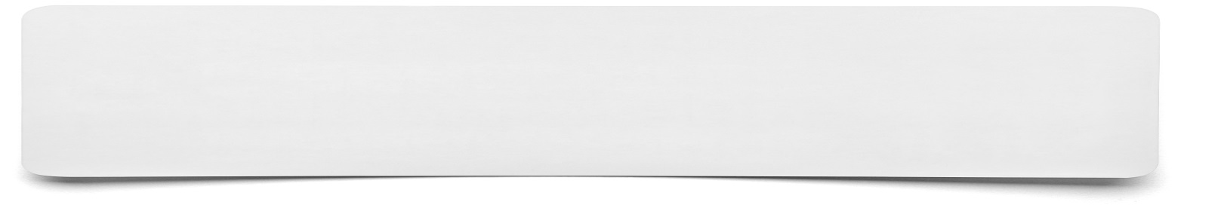**Diagram**



**Create a diagram using the information that you have been given. This should use a combination of geometric shapes and text to show the information.**