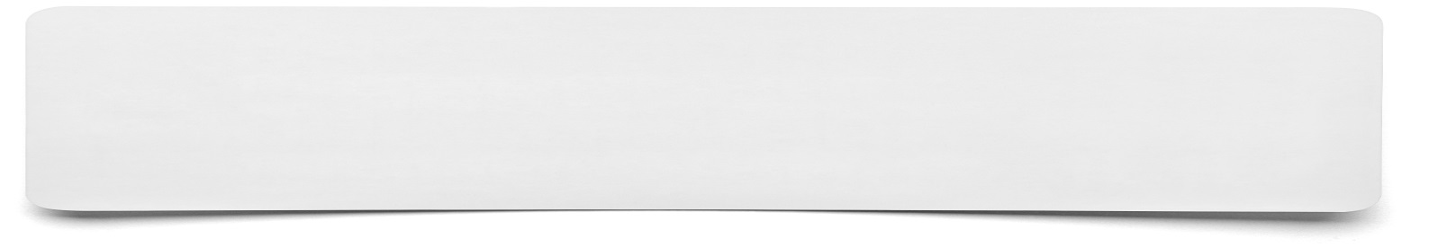**Flowchart**

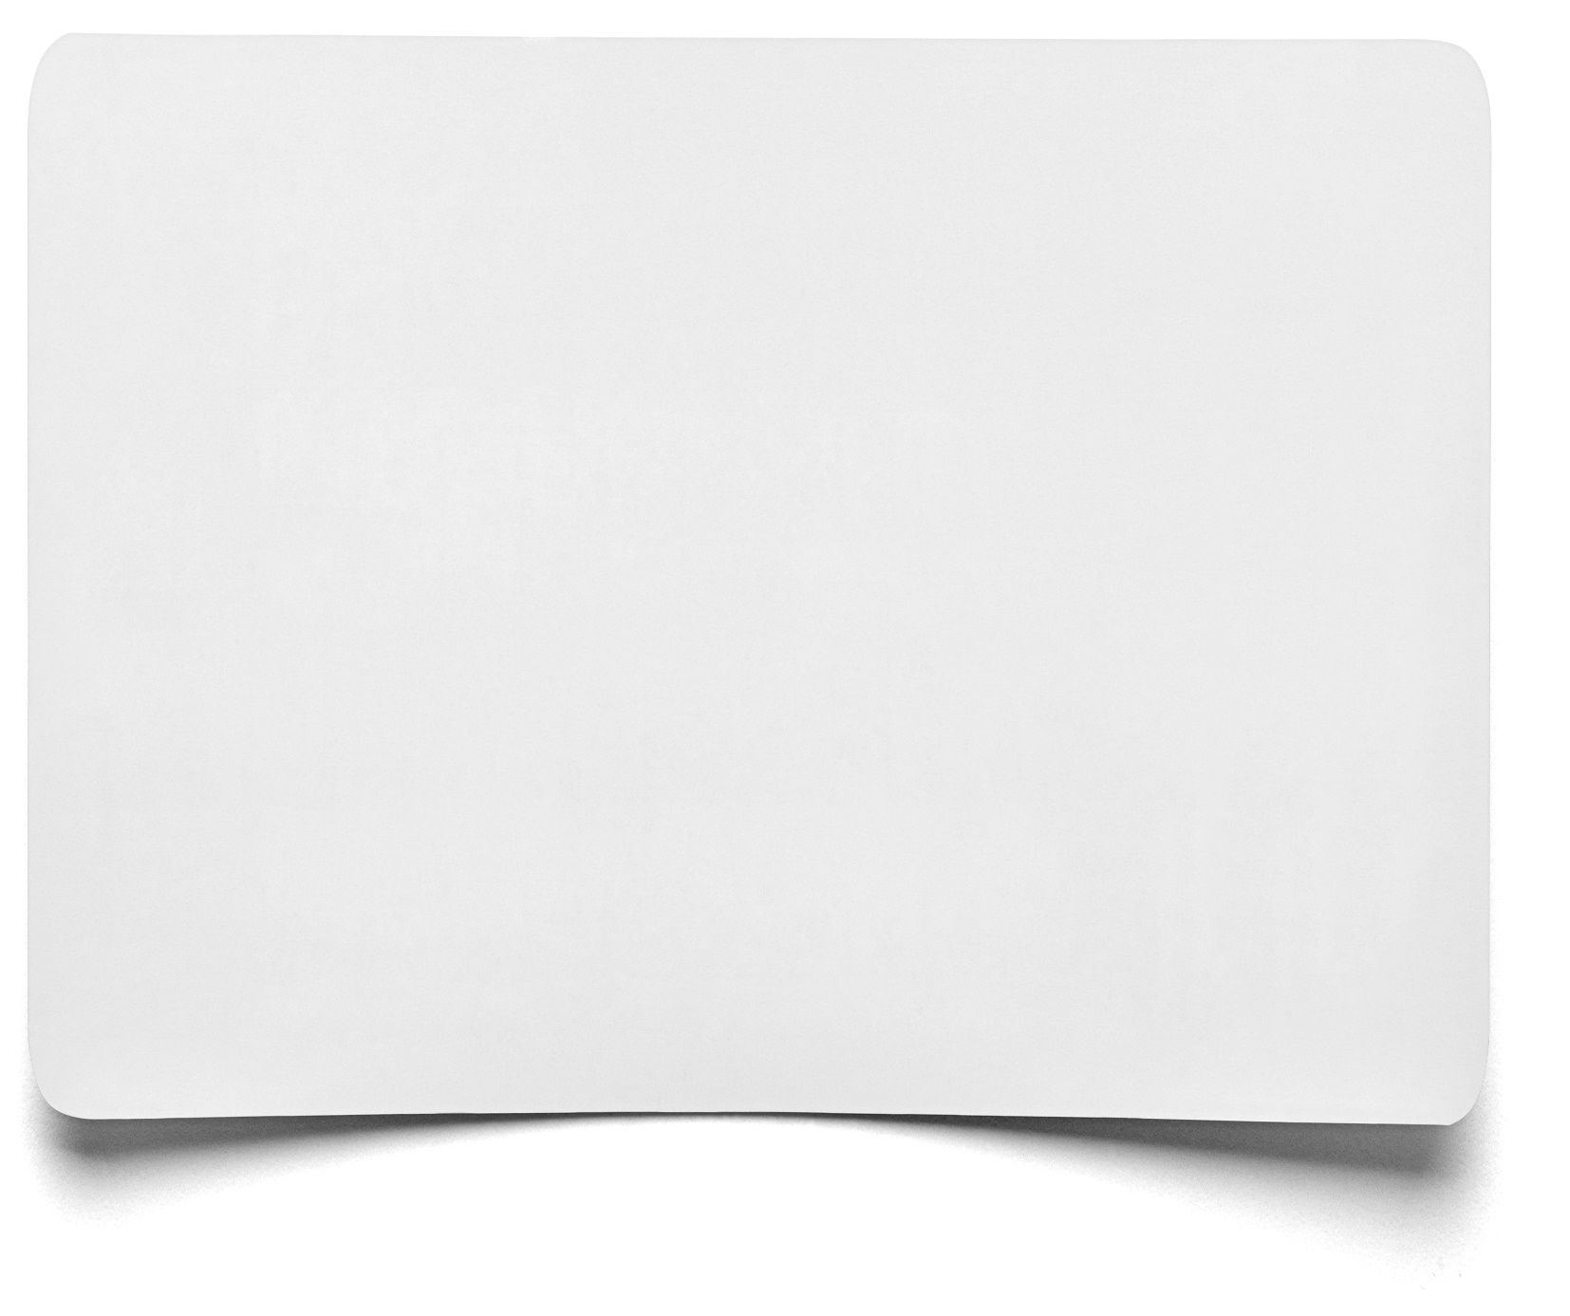

This shape represents the first and last piece of information/instruction

This shape represents a check

This shape represents a piece of information or instruction