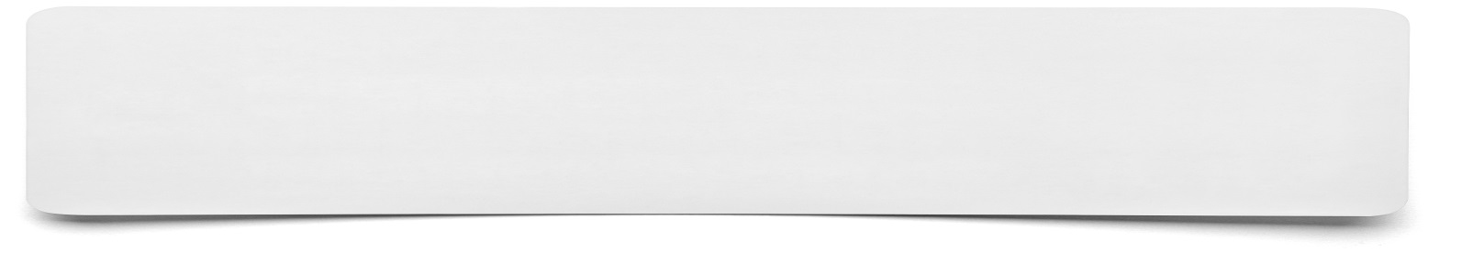**Infographic**



**Key information to be included on my infographic…**

**My infographic idea…**