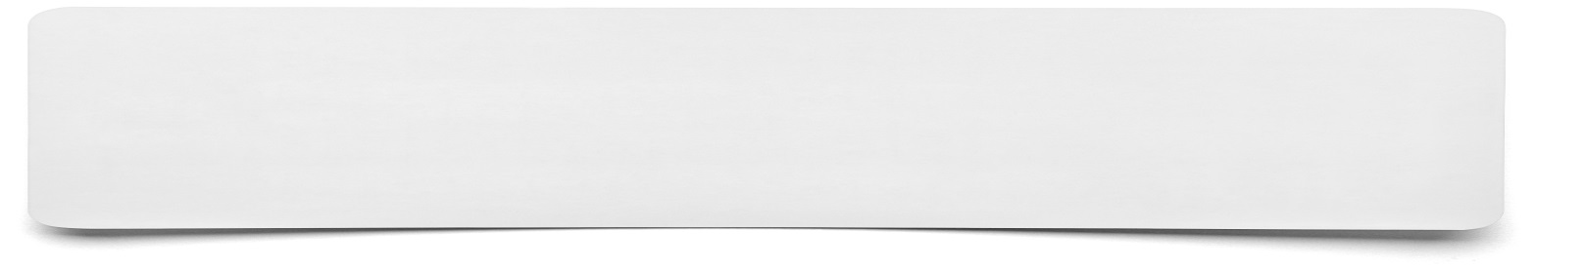**Letter**



**Key information to be included within my letter…**

