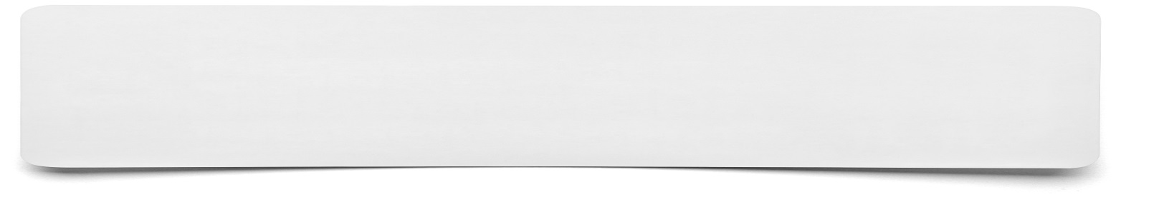**Picture Mind Map**



**Present the information that you have been given as a mind map using pictures only. Represent each point related to the task using a sketch, only use text if really necessary.**