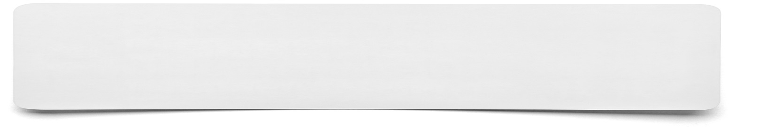**Postcard**



**List the points that you wish to include on your postcard……**