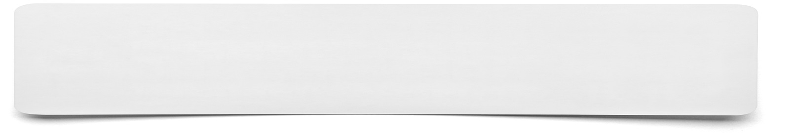**Relationship Diagram**



**List the points that you wish to include within your diagram……**