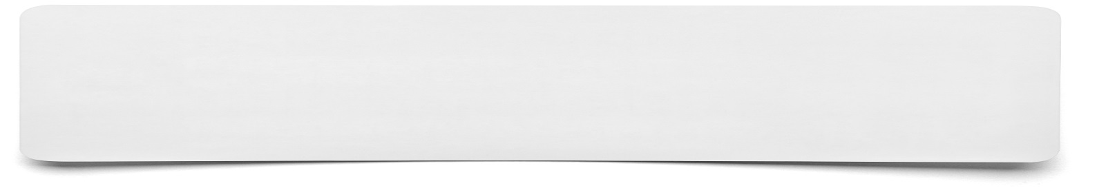**Sketch (series)**

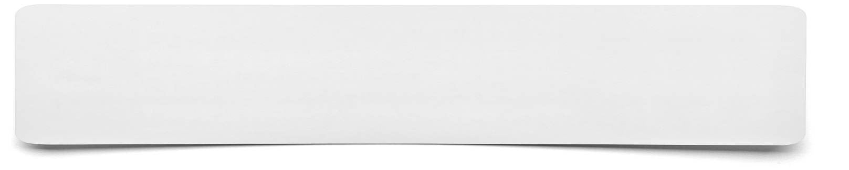

**List the points that you wish to include within your sketches and any ideas about how to show them as pictures……**