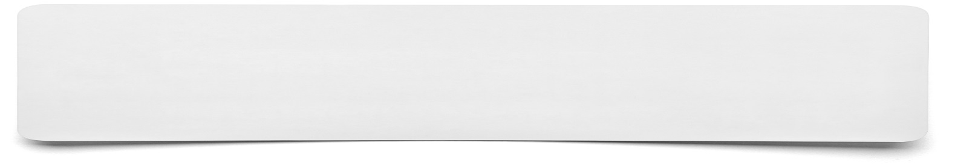**Sketch**

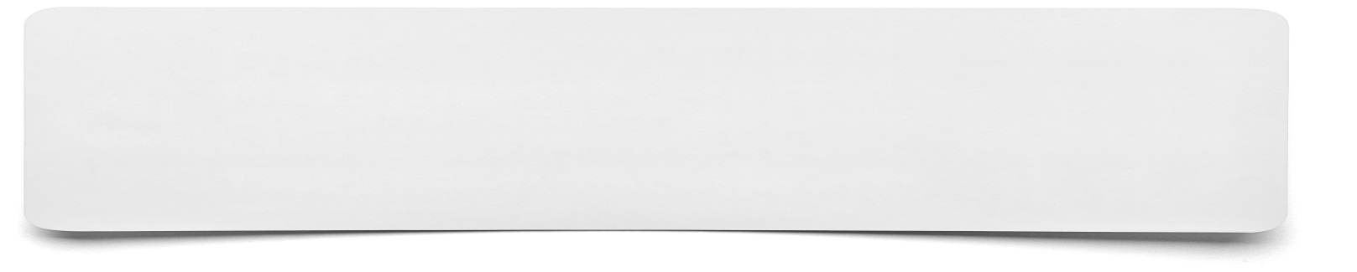

**List the points that you wish to include within your sketch and any ideas about how to show them as pictures within your sketch……**