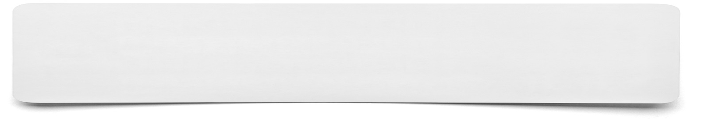**Song or rap**



**Present the information that you have been given in the form of a song or a rap. This needs to be kept to 60 seconds long. You will need to plan what information you are going to sing about and consider if you need to make any prompt cards which you could use to aid you.**



**Lyrics for my song or rap…**