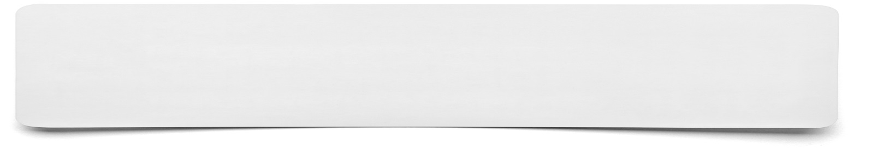**Summary Speech**

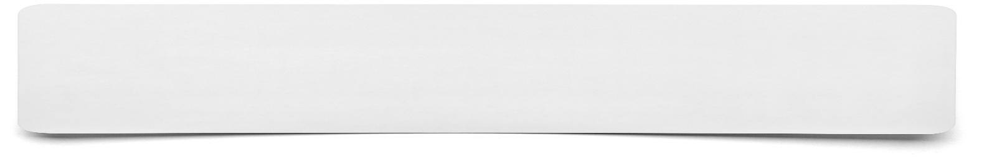

**You will need to produce a written draft summary speech to last for no more than 20 seconds.**

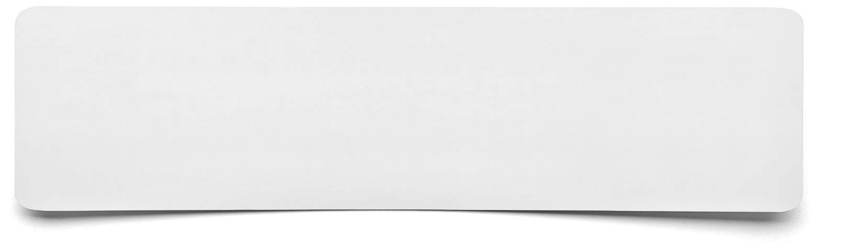****

**Key points to include…**