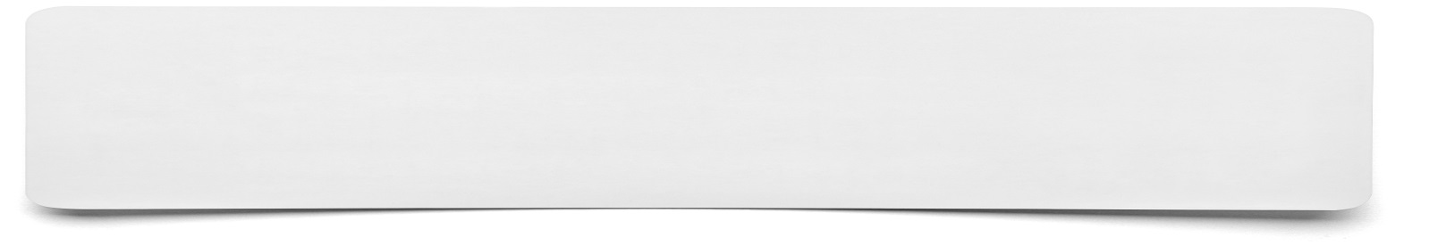**Summary Tree**



**Draw a tree with a trunk, 5 main branches and two small branches on each main branch. Place the main point from your learning onto the trunk, the next 5 most important points onto each of the branches. Finally for each of these 5 points give 2 additional details.**