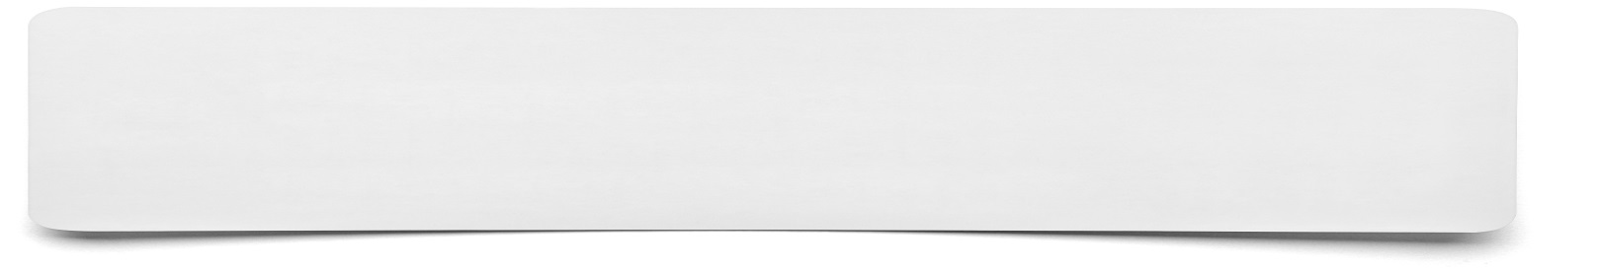**Summary spinner**

Point to go onto spinner…

Point to go onto spinner…

Point to go onto spinner…

Point to go onto spinner…

Point to go onto spinner…

Point to go onto spinner…

Point to go onto spinner…

Point to go onto spinner…