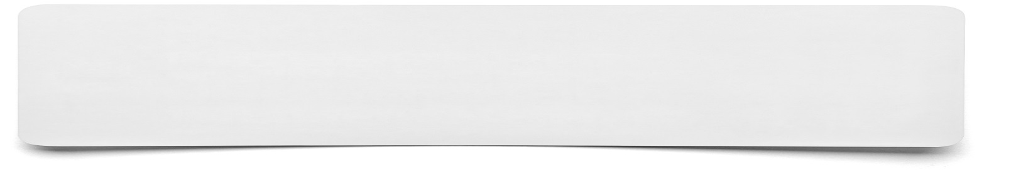 **Written Interview**

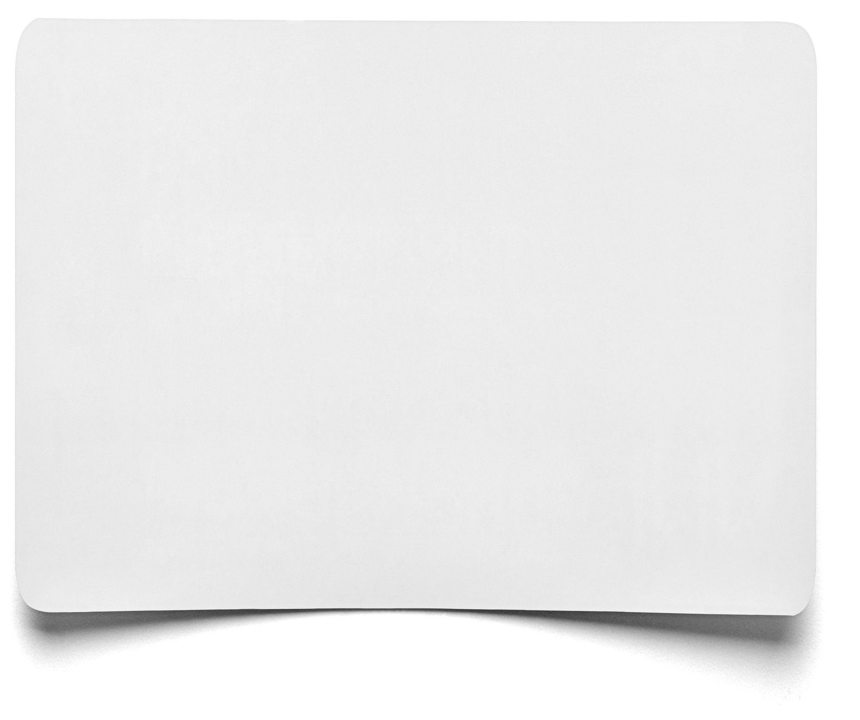

|  |  |
| --- | --- |
| **Point** | **Answer** |
|  |  |
|  |  |
|  |  |
|  |  |
|  |  |
|  |  |