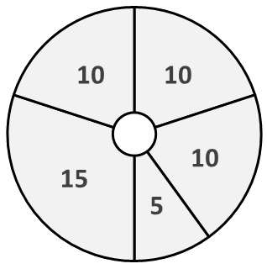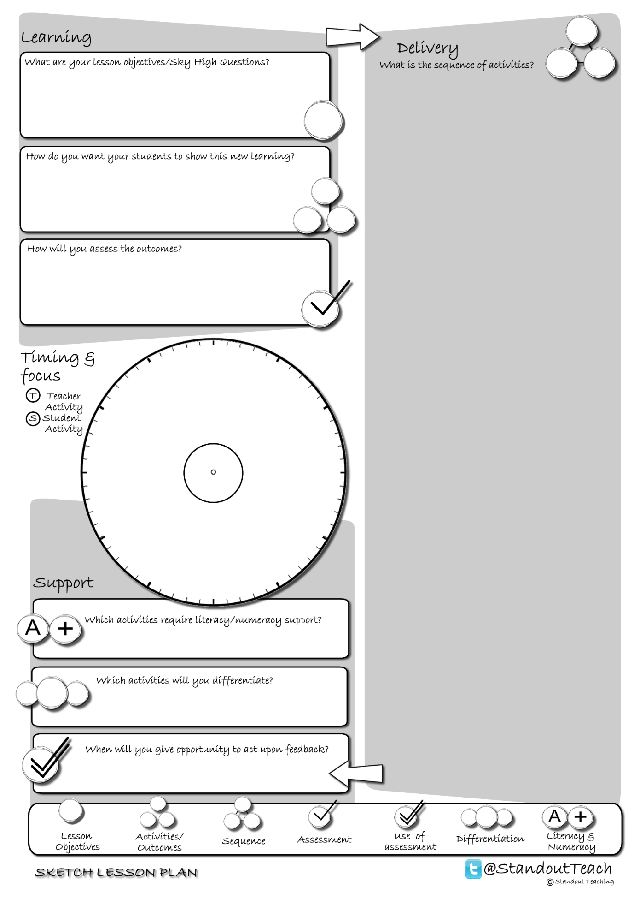

**S**

**S**

**S**

**S**

**S**

|  |
| --- |
| **Activity 1 : (10 minute) Starter: Individual Activity** |
| [Connect- SUB](http://www.standoutteaching.co.uk/portfolio/connect-sub/) : Students are given a piece of text, to which they will then apply SUB. Firstly they scan the text, then underline the key points before finally drawing a box around the keywords. |
| **Activity 2 : (10 minute) Paired Activity** |
| [I'm the Teacher GAP](http://www.standoutteaching.co.uk/portfolio/im-the-teacher-gap/) : Around the room is a range of tasks for students to visit and undertake. Each task has GAP applied to differentiate and challenge the students. Students will have 5 minutes to complete each task. |
| **Activity 3 : (5 minute) AFL: Self Assessment** |
| [BIG Assessment Checks Pt1](http://www.standoutteaching.co.uk/portfolio/big-assessment-and-checks-pt1/) : Using the BIG Lined Paper worksheet students will reflect upon a piece of work that they have completed and state several areas to develop further (Part 1). This is a 3 stage process- baseline, improving and checking. |
| **Activity 5 : (15 minute) Paired Activity** |
| [Learning Blooms- Writing](http://www.standoutteaching.co.uk/portfolio/learning-blooms-writing/) : Students undertake a Learning Blooms exercise, selecting from one of eight tasks with a focus on written outcomes. They will also incorporate GAP differentiation into their task. |
| **Activity 6 : (10 minute) Plenary: Individual Activity** |
| [BIG Assessment Checks Pt3](http://www.standoutteaching.co.uk/portfolio/big-assessment-and-checks-pt3/) : This is part 3, the final stage of this process. Students have already identified areas to improve and then applied the findings to their work. The final stage is to check against the targets they have set and ensure they have completed them all. |