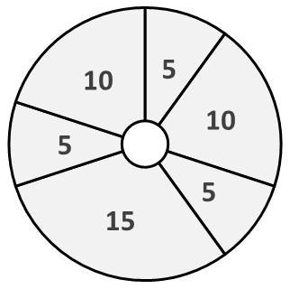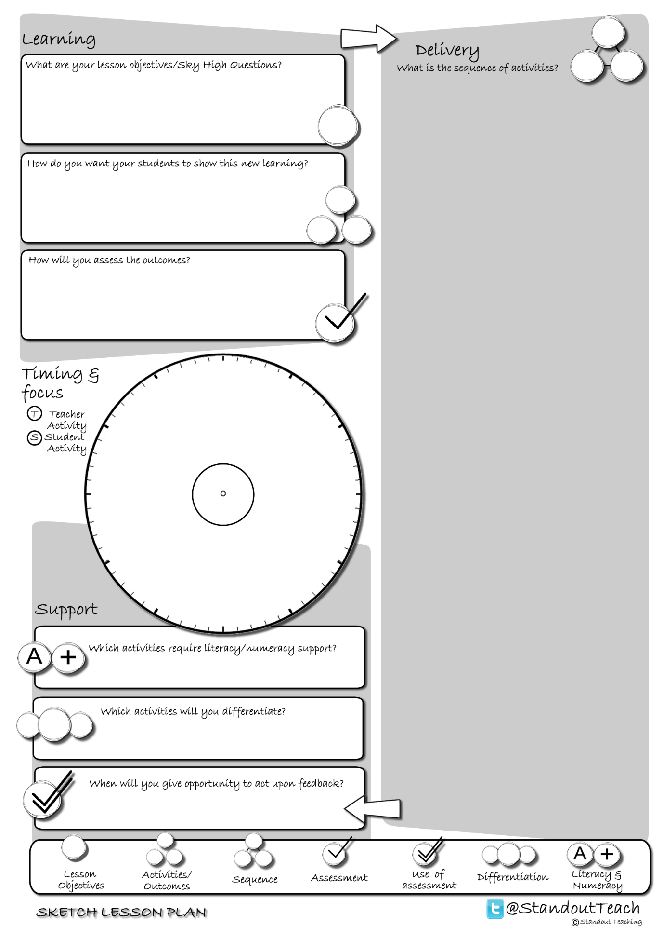

**T**

**S**

**S**

**S**

**S**

**S**

|  |
| --- |
| **Activity 1 : (5 minute) Starter: Individual Activity** |
| [Text me!](http://www.standoutteaching.co.uk/portfolio/text-me/) : Students are issued with a text speak phrase to decipher. They will have 60 seconds to complete the exercise. They then feedback to the class what they think it said. |
| **Activity 2 : (10 minute) Paired Activity** |
| [Mysteries](http://www.standoutteaching.co.uk/portfolio/mysteries/) : Students have a set of questions and multiple pieces of text. They must try to identify which questions are relevant to the text they have and try to answer them. They then swap and repeat the process. |
| **Activity 3 : (5 minute) AFL: Self Assessment** |
| [BIG Assessment Checks Pt1](http://www.standoutteaching.co.uk/portfolio/big-assessment-and-checks-pt1/) : Using the BIG Lined Paper worksheet students will reflect upon a piece of work that they have completed and state several areas to develop further (Part 1). This is a 3 stage process- baseline, improving and checking. |
| **Activity 4 : (15 minute) Individual Pupil Activity** |
| [Learning Blooms- Visual](http://www.standoutteaching.co.uk/portfolio/learning-blooms-visual/) : Students undertake a Learning Blooms exercise, selecting from one of eight tasks with a focus on visual outcomes. They will also incorporate GAP differentiation into their task. |
| **Activity 5 : (5 minute) AFL: Self Assessment** |
| [BIG Reflecting Circles Pt3](http://www.standoutteaching.co.uk/portfolio/big-reflecting-circles-pt3/) : This is part 3, the final stage of this process. Students have already identified areas to improve and then applied the findings to their work. The final stage is to check against the targets they have set and ensure they have completed them all. |
| **Activity 6 : (10 minute) Plenary: Teacher Led** |
| [And the mistake is?](http://www.standoutteaching.co.uk/portfolio/and-the-mistake-is/) : Students are to watch a short activity/look at a piece of work and record any mistakes that they see. In pairs they then compare observations and feedback to the class. |