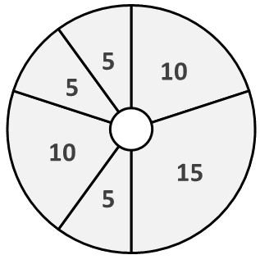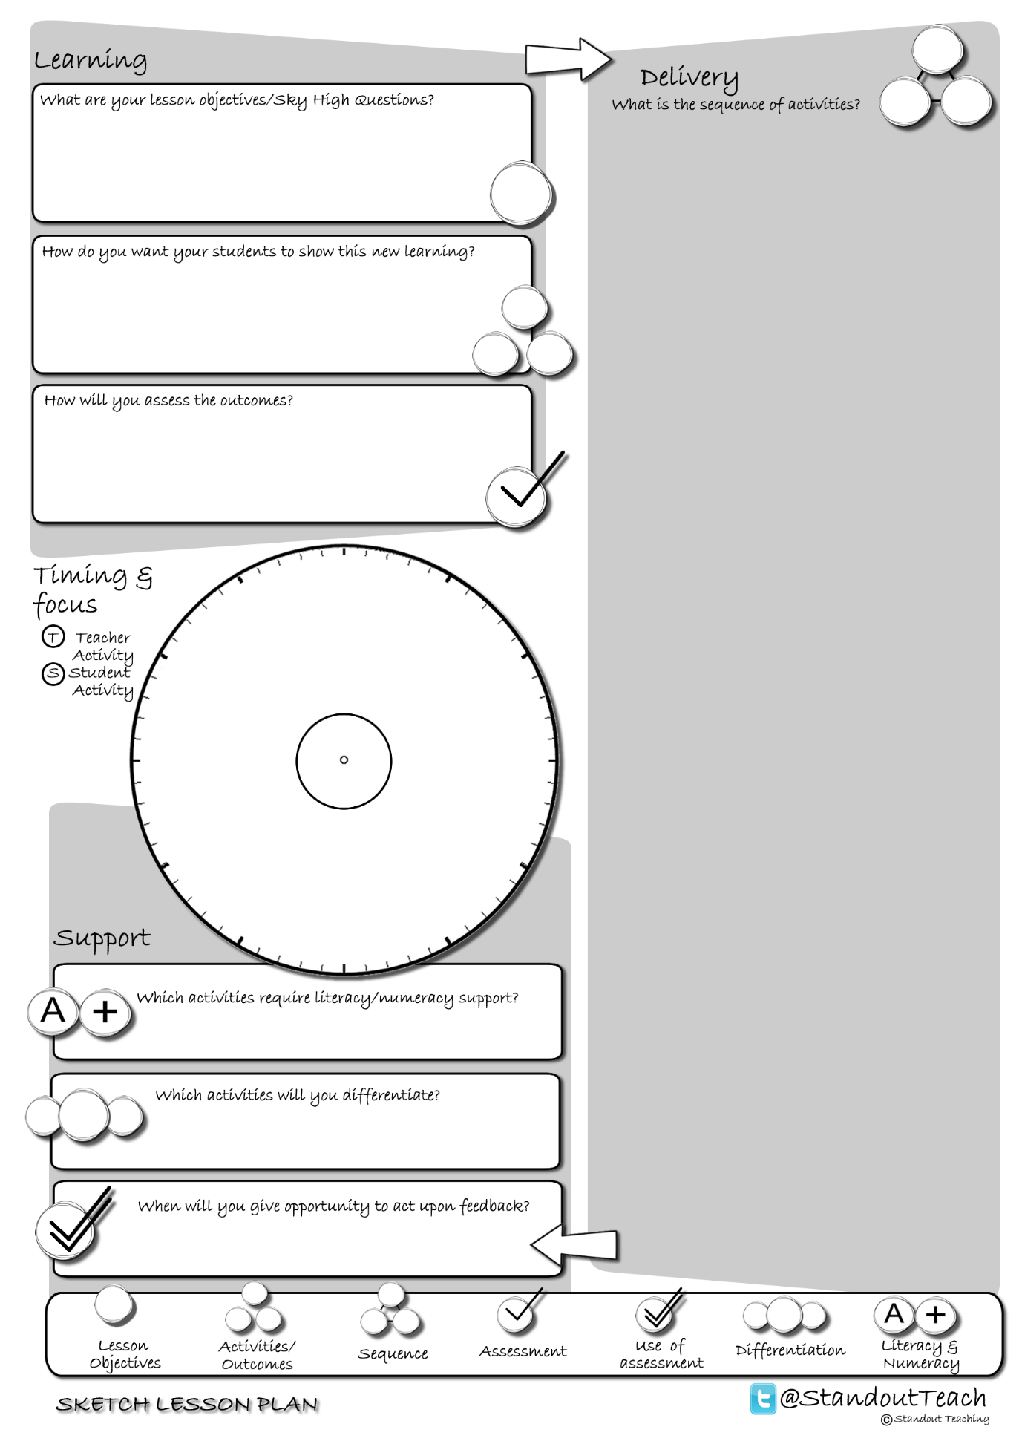

**S**

**T**

**S**

**S**

**S**

**S**

|  |
| --- |
| **Activity 1 : (10 minute) Starter: Group Activity** |
| [10 Questions](http://www.standoutteaching.co.uk/portfolio/10-questions/) : In groups of 4 students are given a word where 3 group members must ask a maximum of 10 questions in order to identify the word known by the 4th group member. |
| **Activity 2 : (15 minute) Individual Pupil Activity** |
| [Another Way GAP](http://www.standoutteaching.co.uk/portfolio/another-way-gap/) : Students are issued with a piece of text which is differentiated and signposted with GAP. They are then given the option to convert it into a mind map, storyboard, bullet point list or flow chart. |
| **Activity 3 : (5 minute) AFL: Self Assessment** |
| [BIG Circles Pt1](http://www.standoutteaching.co.uk/portfolio/big-circles-pt1/) : Using the Circles worksheet students will reflect upon a piece of work that they have completed and state 3 areas to develop further (Part 1). This is a 3 stage process- baseline, improving and checking. |
| **Activity 4 : (10 minute) Individual Pupil Activity** |
| [Individual Blooms Comparison](http://www.standoutteaching.co.uk/portfolio/individual-blooms-comparison/) : Students choose at least 2 points from the task that they have been given and compare them looking at their similarities and differences. Students can maximise the content of their comparison by using the GAP tasks. |
| **Activity 5 : (5 minute) AFL: Questioning - Teacher Led** |
| [Q-Time Bouncing Questions](http://www.standoutteaching.co.uk/portfolio/q-time-bouncing-questions/) : Students are questioned in relation to their learning using the Q-time process- Question, Quiet, Quiz and Query. The later part of the sequence incorporates question bouncing led by the students. |
| **Activity 6 : (5 minute) Plenary: Individual Activity** |
| [BIG Circles Pt3](http://www.standoutteaching.co.uk/portfolio/big-circles-pt3/) : This is part 3, the final stage of this process. Students have already identified areas to improve and then applied the findings to their work. The final stage is to check against the targets they have set and ensure they have completed them all. |