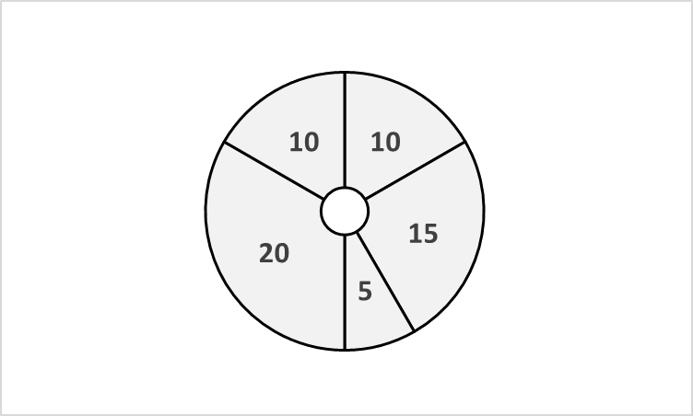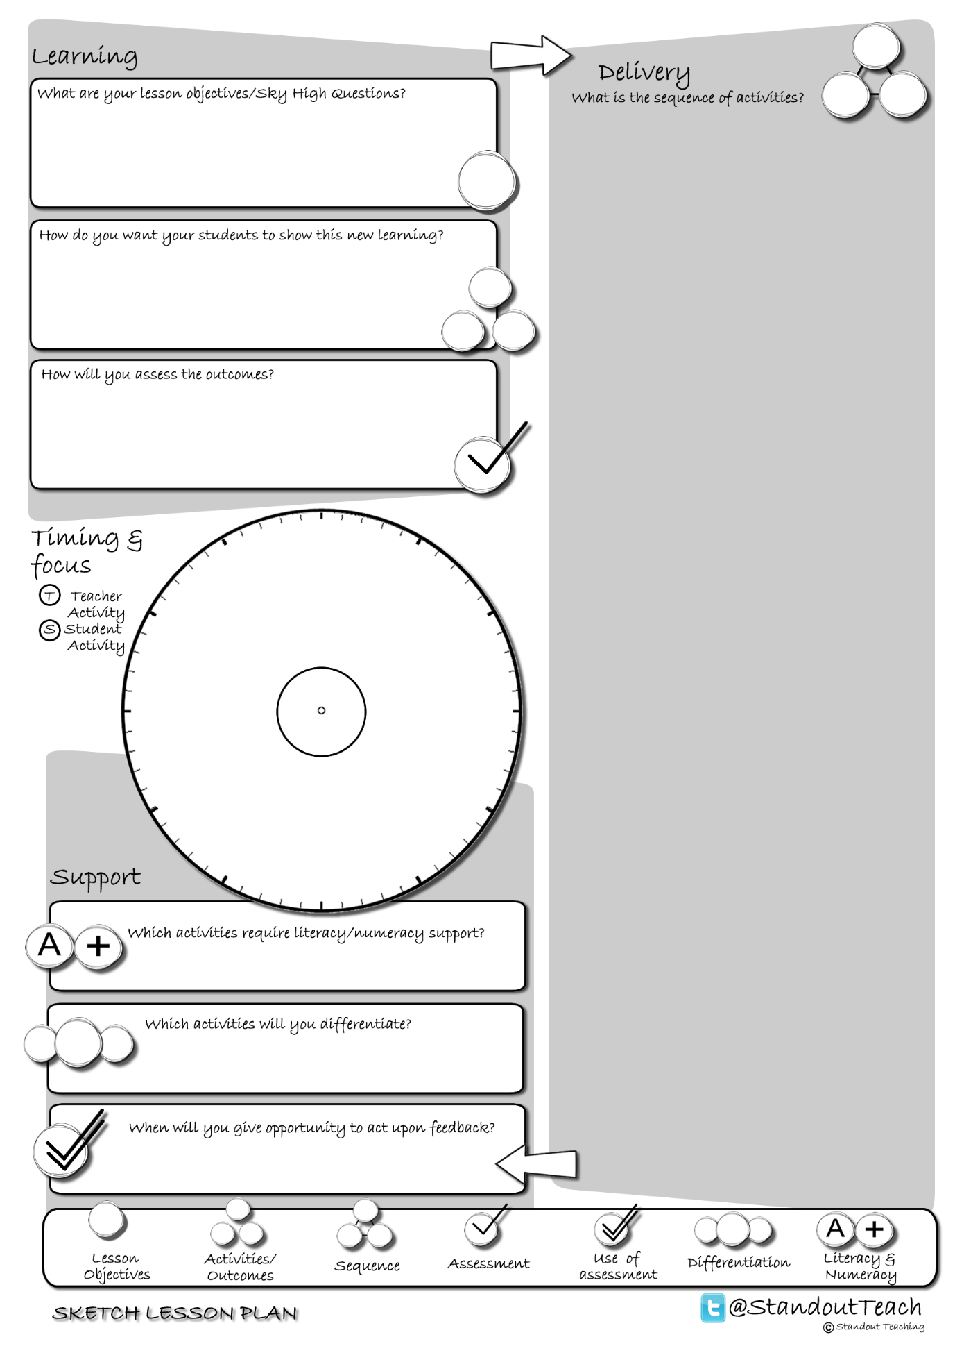

**S**

**S**

**S**

**S**

**S**

|  |
| --- |
| **Activity 1 : (10 minute) Starter: Individual Activity** |
| [Sky High Image (GAP)](http://www.standoutteaching.co.uk/portfolio/sky-high-image-gap/) : Students read the Sky High Question and underline the keywords. Students then reinterpret the Sky High Question as a picture. The GAP element allows notes to be added to support. |
| **Activity 2 : (15 minute) Individual Pupil Activity** |
| [Another Way GAP](http://www.standoutteaching.co.uk/portfolio/another-way-gap/) : Students are issued with a piece of text which is differentiated and signposted with GAP. They are then given the option to convert it into a mind map, storyboard, bullet point list or flow chart. |
| **Activity 3 : (5 minute) AFL: Paired Assessment** |
| [Green Pen- Comment Spaghetti](http://www.standoutteaching.co.uk/portfolio/green-pen-comment-spaghetti/) : Students draw a spaghetti line and then record positives about their work on each upward curve and areas to improve on each downward curve. Peers are also asked to reflect on the work using the same method. |
| **Activity 4 : (20 minute) Individual Pupil Activity** |
| [Connect- PEE](http://www.standoutteaching.co.uk/portfolio/connect-pee/) : Students are to write an argument using the PEE formula to construct it. They must make their point, provide evidence to support this then explore the point using the evidence to reinforce. |
| **Activity 5 : (10 minute) Plenary: Paired Activity** |
| [Sketch a thought GAP](http://www.standoutteaching.co.uk/portfolio/sketch-a-thought-gap/) : Students are to reflect upon what they have learnt through drawing a sketch to summarise. To extend it they are limited to one sketch only and need to include reference to a key point. |