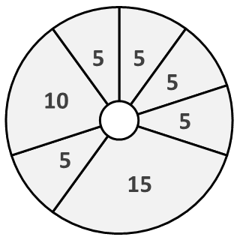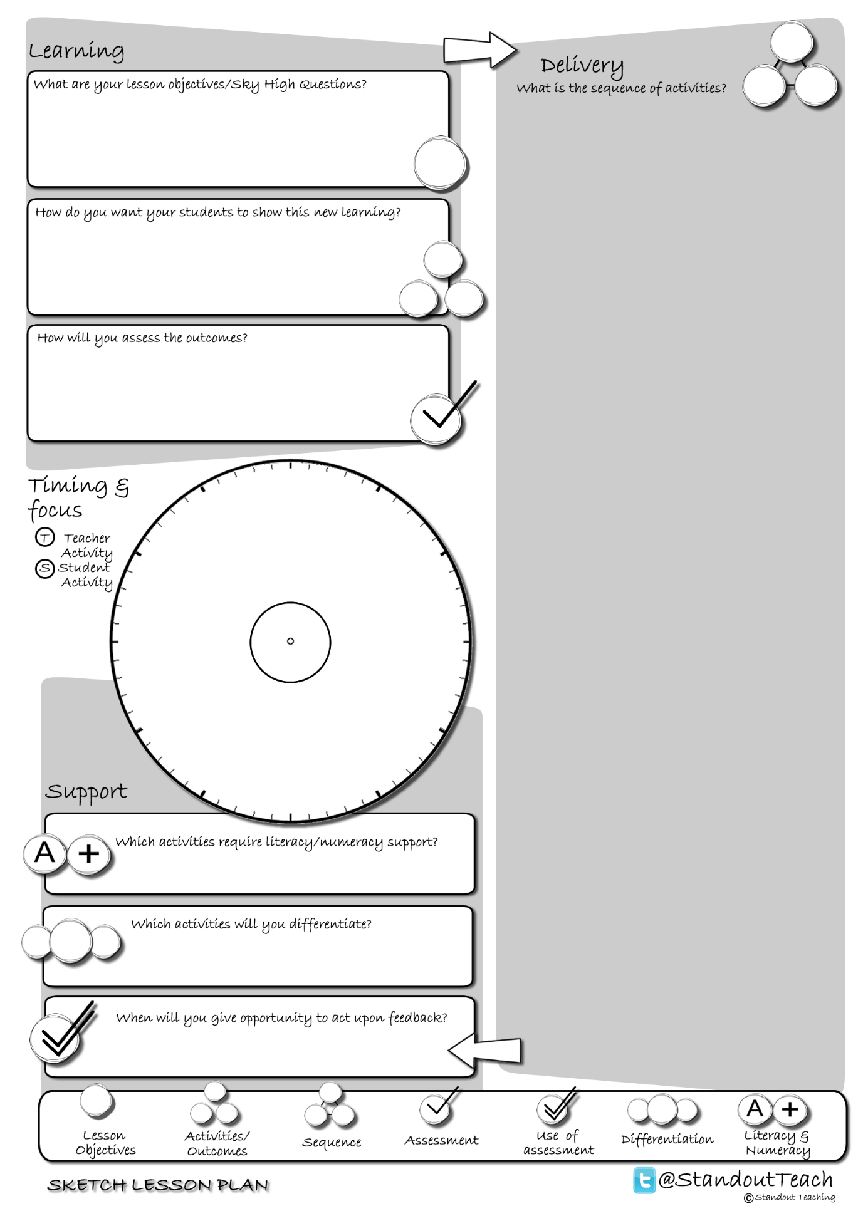

**S**

**S**

**S**

**S**

**T**

**T**

**S**

|  |
| --- |
| **Activity 1 : (5 minute) Starter: Individual Activity** |
| [Picture label](http://www.standoutteaching.co.uk/portfolio/picture-label/) : Students are to annotate a picture that they have been given to highlight the key points. They then swap with a partner to add any points that may have been missed before providing feedback to the class. |
| **Activity 2 : (5 minute) Teacher Led** |
| [Lesson Basics- Demonstration](http://www.standoutteaching.co.uk/portfolio/lesson-basics-demonstration/) : Teacher demonstrates to the class a particular task. Students observe the teacher and make notes/answer questions related to what they see. |
| **Activity 3 : (5 minute) AFL: Questioning - Teacher Led** |
| [Q-Time Questioning](http://www.standoutteaching.co.uk/portfolio/4114/) : Students are questioned in relation to their learning using the Q-time process- Question, Quiet, Quiz and Query. This is used to inform the structure of future learning within the lesson. |
| **Activity 4 : (15 minute) Individual Pupil Activity** |
| [Lesson Basics- Practical](http://www.standoutteaching.co.uk/portfolio/lesson-basics-practical-demonstration/) : Students are given the opportunity to undertake a practical activity following guidance from the teacher. |
| **Activity 5 : (5 minute) AFL: Paired Assessment** |
| [BIG Paper and Green Pen](http://www.standoutteaching.co.uk/portfolio/big-paper-and-green-pen/) : Having completed a set piece of work, students are given the opportunity to use Green Pen to reflect. This is then followed with the opportunity to apply what they have identified. |
| **Activity 6 : (10 minute) Individual Pupil Activity** |
| [Lesson Basics- Practical](http://www.standoutteaching.co.uk/portfolio/lesson-basics-practical-demonstration/) : Students are given the opportunity to undertake a practical activity following guidance from the teacher. |
| **Activity 7 : (5 minute) Plenary: Individual Activity** |
| [Green pen- How could?](http://www.standoutteaching.co.uk/portfolio/green-pen-how-could/) : Students are to reflect on their work through answering the following questions regarding it- 'What went well?' and 'Even better if?' |