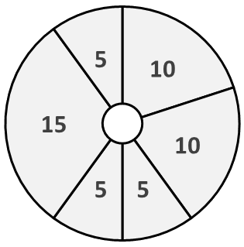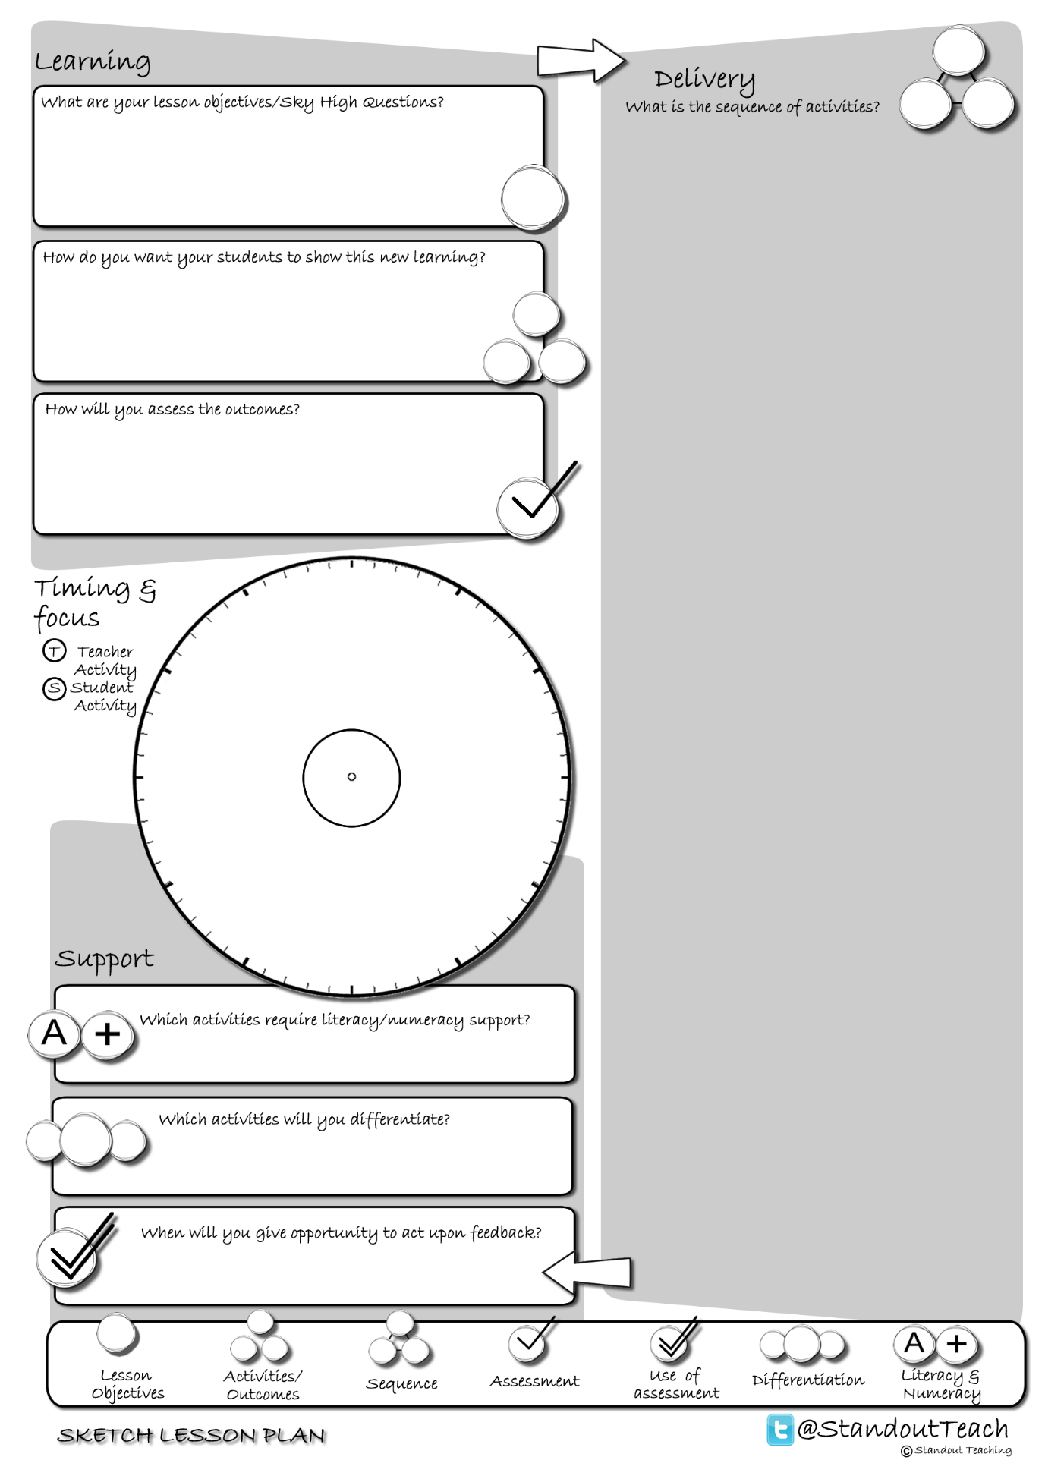

**S**

**S**

**T**

**S**

**S**

**T**

|  |
| --- |
| **Activity 1 : (10 minute) Starter: Teacher Led** |
| [Hide and seek GAP](http://www.standoutteaching.co.uk/portfolio/hide-seek-gap/) : Around the room are a set of clues related to the theme for the lesson's learning. Students are to visit the clues and try to answer them. GAP is applied to each clue to add challenge if required. |
| **Activity 2 : (10 minute) Individual Pupil Activity** |
| [Lesson Basics- Reading](http://www.standoutteaching.co.uk/portfolio/lesson-basics-reading/) : Students are given a piece of text related to the lessons learning to read. |
| **Activity 3 : (5 minute) AFL: Paired Assessment** |
| [Odd One Out](http://www.standoutteaching.co.uk/portfolio/odd-one-out/) : Students are given a set of statements and have 30 seconds to decide which is the odd one out and why. They are then asked to feedback their answers to the class. |
| **Activity 4 : (5 minute) Teacher Led** |
| [Lesson Basics- Explanation](http://www.standoutteaching.co.uk/portfolio/lesson-basics-teacher-explanation/) : Teacher explains the new learning/concept to the class while they listen and observe. Whilst doing this they make notes related to what they see and hear. |
| **Activity 5 : (15 minute) Individual Pupil Activity** |
| [Learning Blooms- Drawing](http://www.standoutteaching.co.uk/portfolio/learning-blooms-drawing/) : Students undertake a Learning Blooms exercise, selecting from one of eight tasks with a focus on drawn outcomes. They will also incorporate GAP differentiation into their task. |
| **Activity 6 : (5 minute) Plenary: Paired Activity** |
| [Sketch a thought GAP](http://www.standoutteaching.co.uk/portfolio/sketch-a-thought-gap/) : Students are to reflect upon what they have learnt through drawing a sketch to summarise. To extend it they are limited to one sketch only and need to include reference to a key point. |