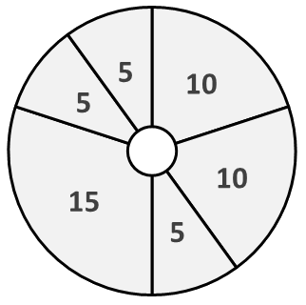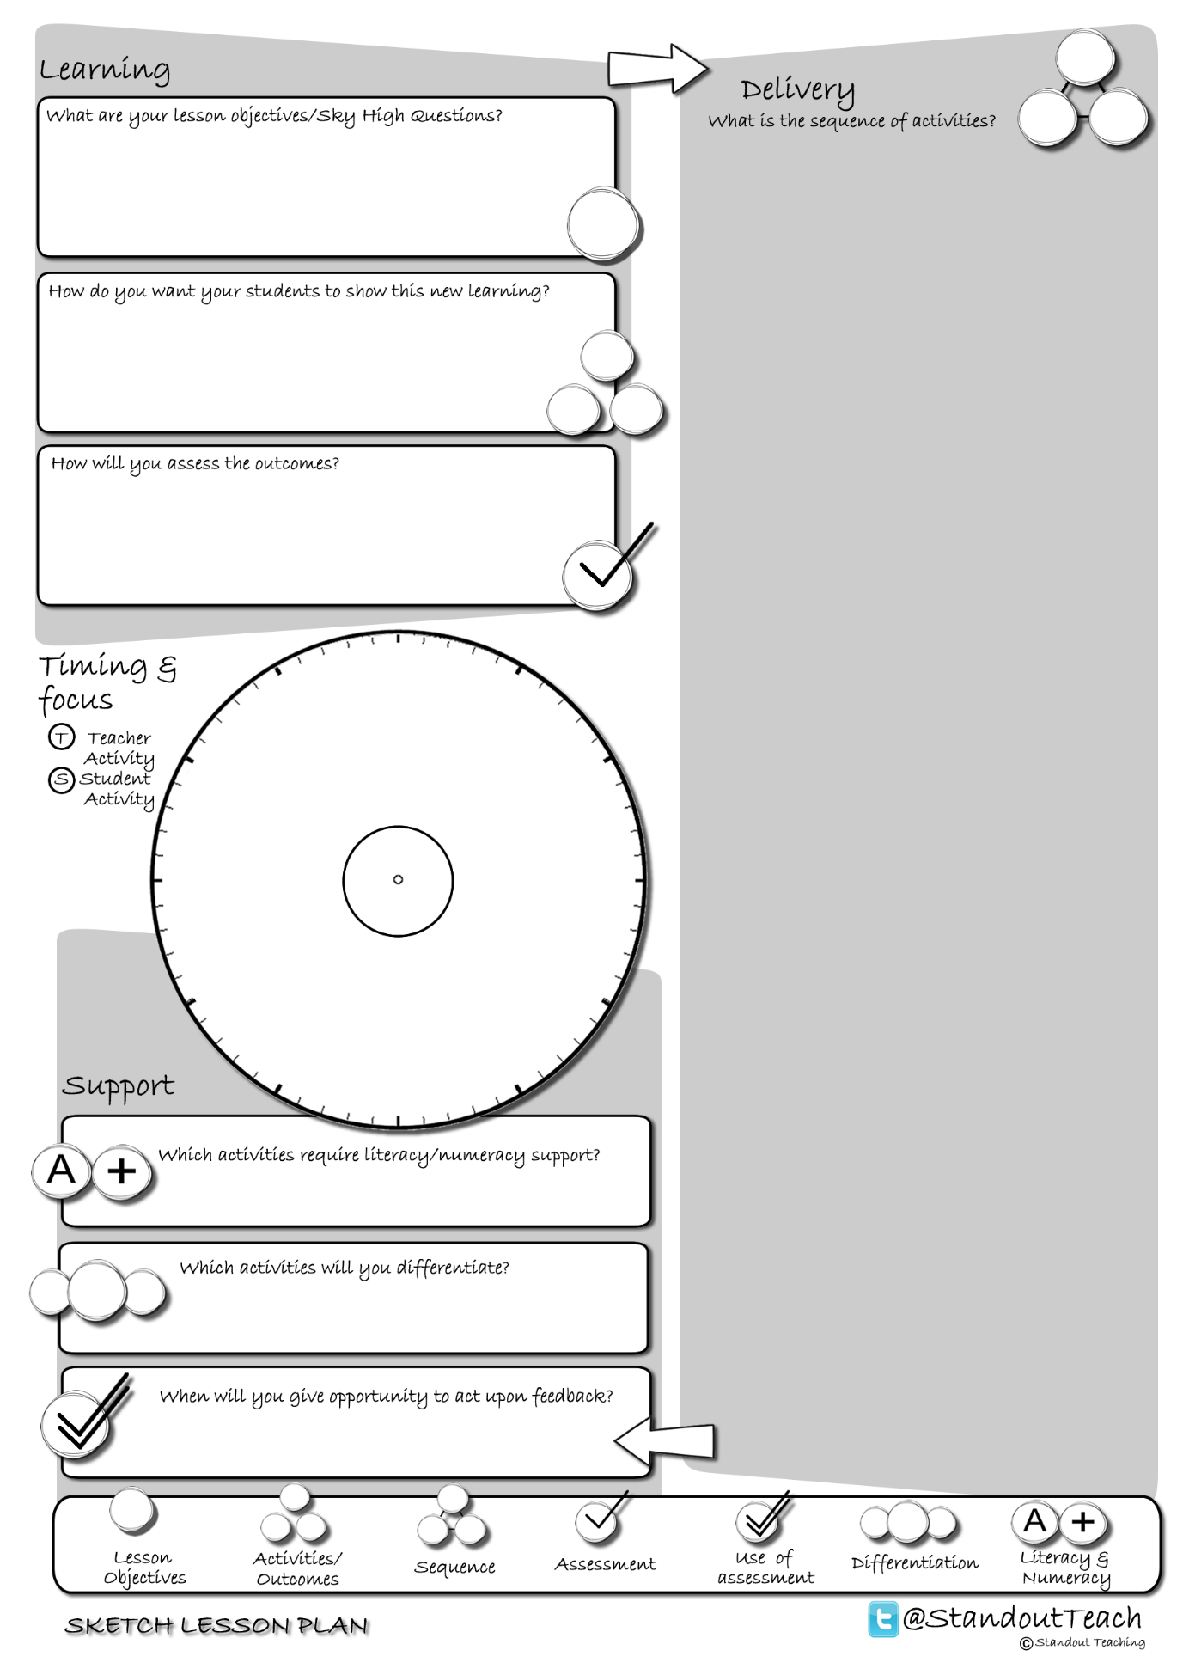

**S**

**S**

**S**

**T**

**S**

**S**

|  |
| --- |
| **Activity 1 : (10 minute) Starter: Group Activity** |
| [Giant mind map](http://www.standoutteaching.co.uk/portfolio/giant-mind-map/) : Students will produce a giant mind map on the floor. Stage1- individuals write/place topics on the floor. Stage 2- in groups they grow each of the topics by placing additional points on the floor. |
| **Activity 2 : (10 minute) Individual Pupil Activity** |
| [Lesson Basics- Demonstration](http://www.standoutteaching.co.uk/portfolio/lesson-basics-demonstration/) : Teacher demonstrates to the class a particular task. Students observe the teacher and make notes/answer questions related to what they see. |
| **Activity 3 : (5 minute) AFL: Questioning - Teacher Led** |
| [Q-Time Questioning](http://www.standoutteaching.co.uk/portfolio/4114/) : Students are questioned in relation to their learning using the Q-time process- Question, Quiet, Quiz and Query. This is used to inform the structure of future learning within the lesson. |
| **Activity 4 : (15 minute) Individual Pupil Activity** |
| [Basics- Extended Writing](http://www.standoutteaching.co.uk/portfolio/lesson-basics-extended-writing/) : Students undertake an extended writing activity related to the lessons learning. |
| **Activity 5 : (5 minute) AFL: Self Assessment** |
| [Green Pen- Reflecting Circles](http://www.standoutteaching.co.uk/portfolio/green-pen-reflecting-circles/) : Using the Reflecting Circles worksheet, students are to record three positive aspects to their work followed by three aspects that they feel they need to improve. |
| **Activity 6 : (5 minute) Plenary: Paired Activity** |
| [Correct statements GAP](http://www.standoutteaching.co.uk/portfolio/correct-statements-gap/) : Students are to visit a range of true or false questions around the classroom (GAP identifies the level of challenge). They then write down if true or false before answers are fed back to the class. |