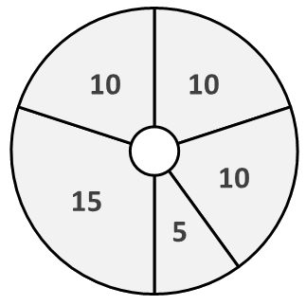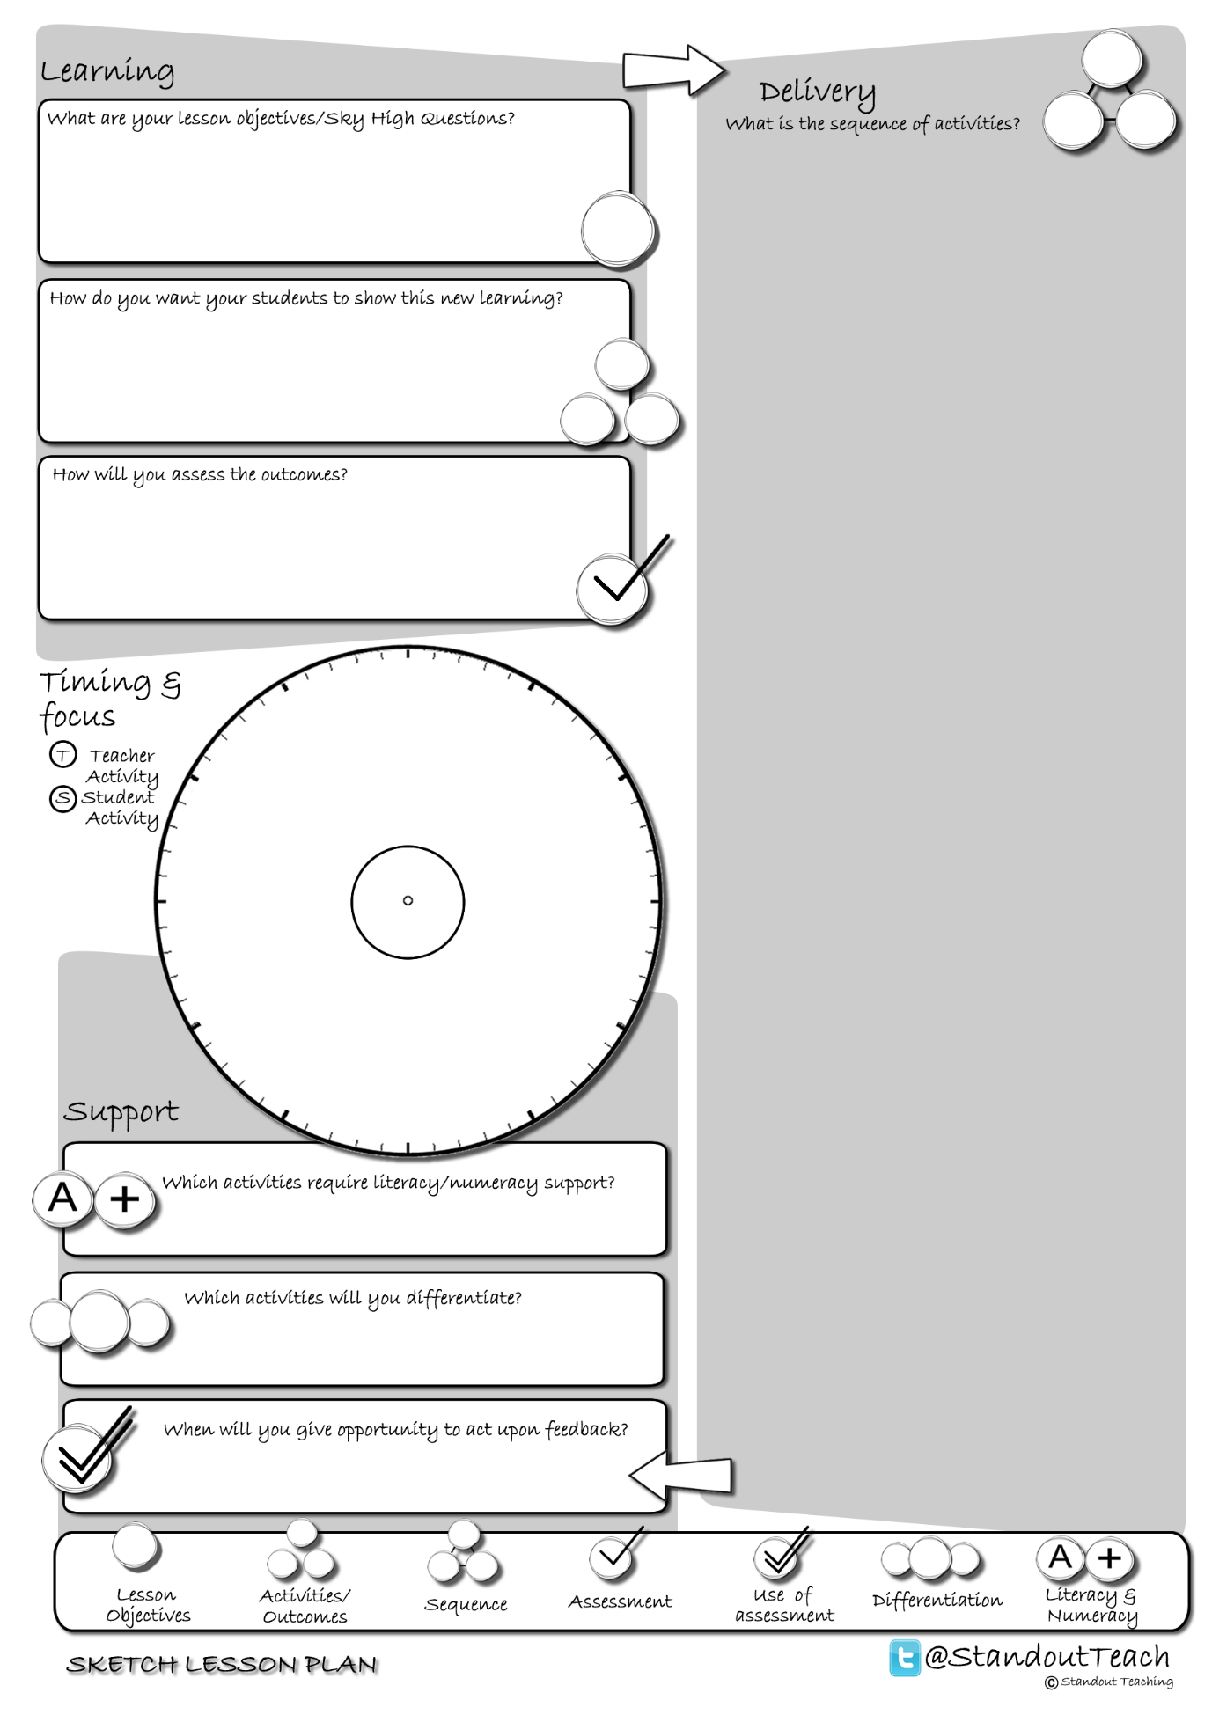

**S**

**S**

**T**

**S**

**S**

|  |
| --- |
| **Activity 1 : (10 minute) Starter: Group Activity** |
| [Vocab Snowball](http://www.standoutteaching.co.uk/portfolio/vocab-snowball/) : Students are given a word and write down what they think the definition is. They then compare and revise definitions in pairs and groups before feeding back to the class. |
| **Activity 2 : (10 minute) Individual Pupil Activity** |
| [Connect- SUB](http://www.standoutteaching.co.uk/portfolio/connect-sub/) : Students are given a piece of text, to which they will then apply SUB. Firstly they scan the text, then underline the key points before finally drawing a box around the keywords. |
| **Activity 3 : (5 minute) AFL: Questioning - Teacher Led** |
| [Q-Time Questioning](http://www.standoutteaching.co.uk/portfolio/4114/) : Students are questioned in relation to their learning using the Q-time process- Question, Quiet, Quiz and Query. This is used to inform the structure of future learning within the lesson. |
| **Activity 4 : (15 minute) Individual Pupil Activity** |
| [Facebook](http://www.standoutteaching.co.uk/portfolio/facebook/) : Students are to convert a piece of text into a Facebook timeline. They will need to create a cover picture, profile picture and produce a timeline of points from the text. |
| **Activity 5 : (10 minute) Plenary: Paired Activity** |
| [A minute to win it! GAP](http://www.standoutteaching.co.uk/portfolio/a-minute-to-win-it-gap/) : Students have 5 minutes to prepare a 60 second presentation. Students will choose from the GAP tasks the level they wish to work at. Once complete they then present to the class. |