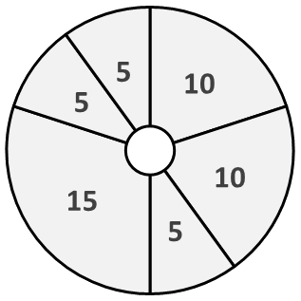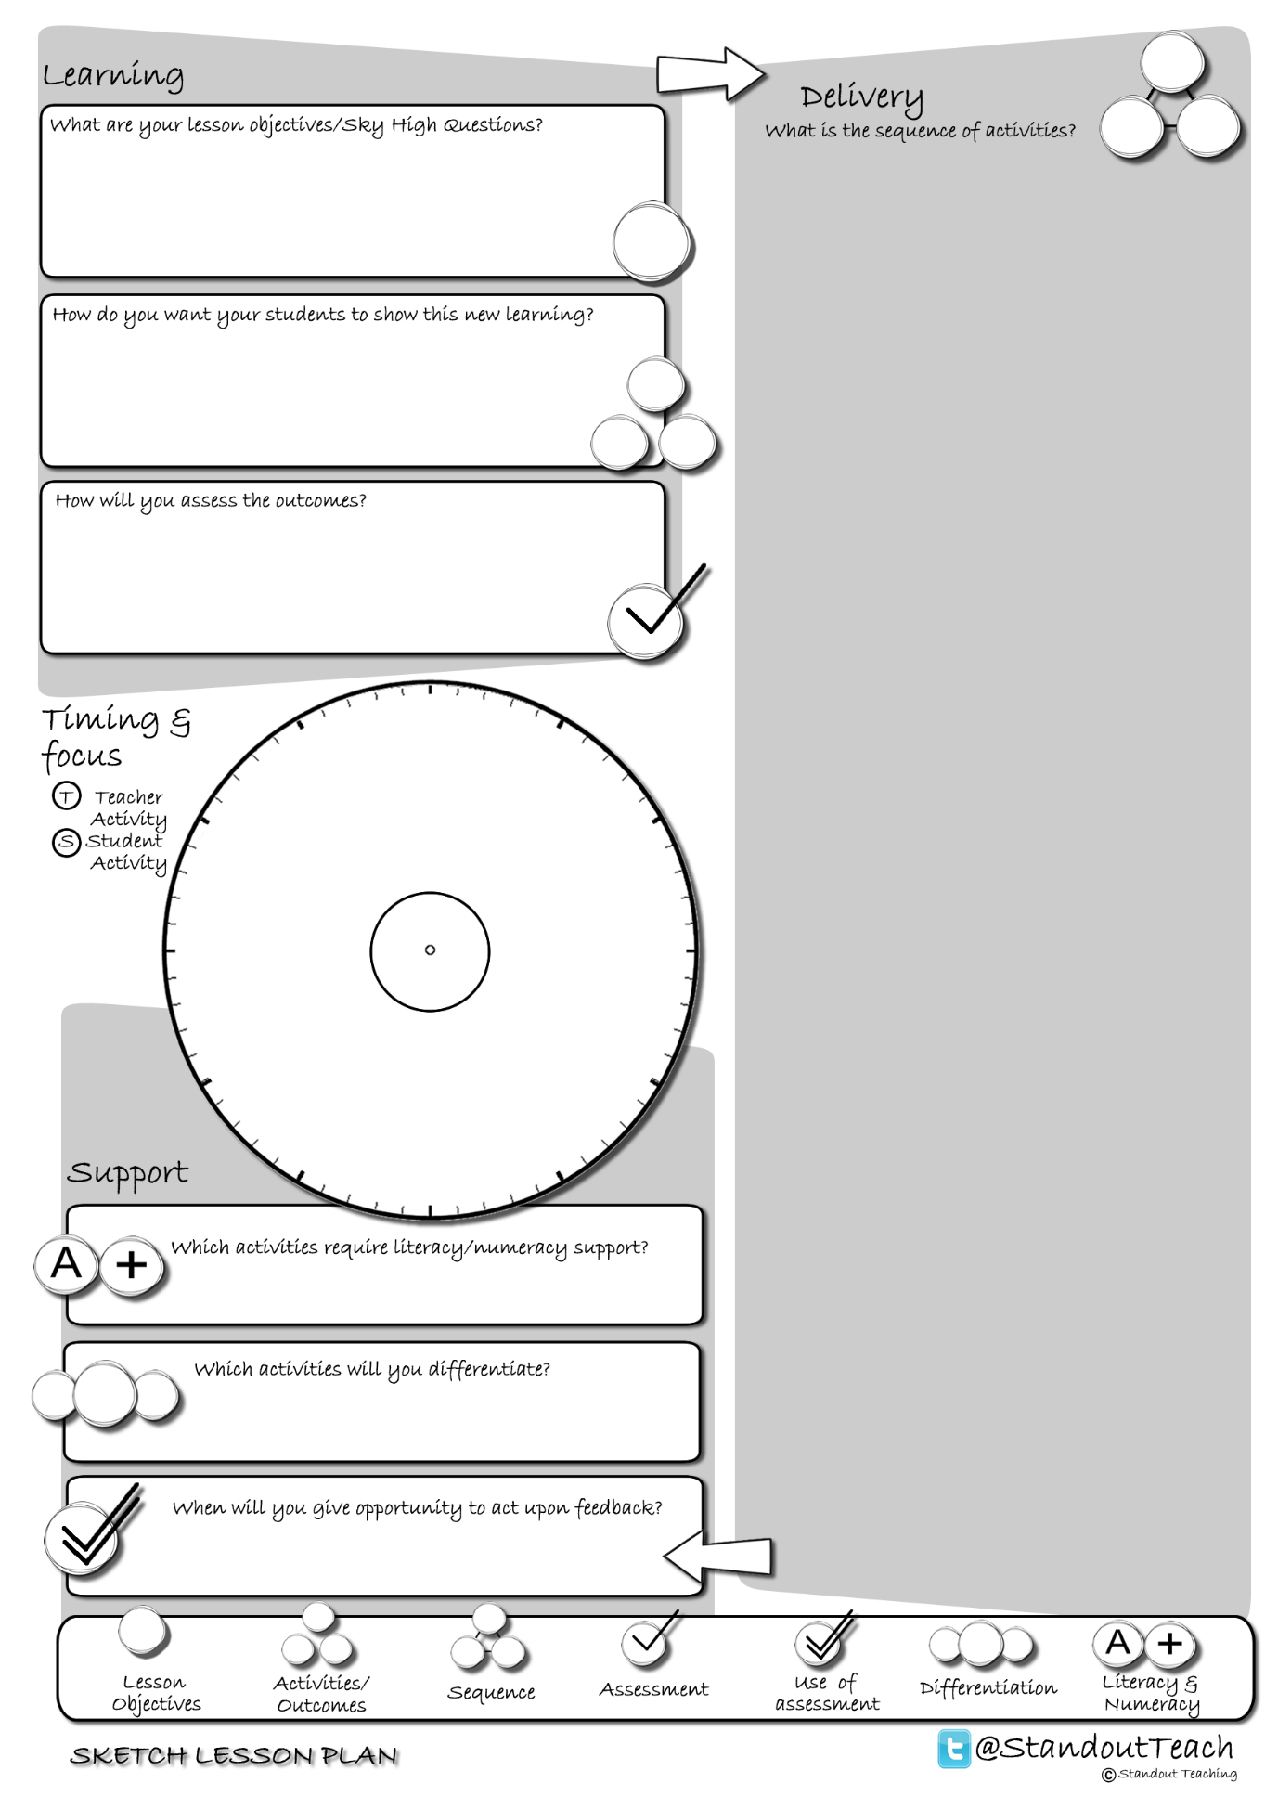

**S**

**S**

**S**

**T**

**T**

**S**

|  |
| --- |
| **Activity 1 : (10 minute) Starter: Individual Activity** |
| [Sky High Mind Map (GAP)](http://www.standoutteaching.co.uk/portfolio/sky-high-mind-map-gap/) : Students read the Sky High Question and underline the keywords. Students create a mind map related to the Sky High Question then expand on each point they have made (GAP task). |
| **Activity 2 : (10 minute) Teacher Led** |
| [Lesson Basics- Demonstration](http://www.standoutteaching.co.uk/portfolio/lesson-basics-demonstration/) : Teacher demonstrates to the class a particular task. Students observe the teacher and make notes/answer questions related to what they see. |
| **Activity 3 : (5 minute) AFL: Questioning - Teacher Led** |
| [Q-Time Questioning](http://www.standoutteaching.co.uk/portfolio/4114/) : Students are questioned in relation to their learning using the Q-time process- Question, Quiet, Quiz and Query. This is used to inform the structure of future learning within the lesson. |
| **Activity 4 : (15 minute) Paired Activity** |
| [Learning Blooms- Various](http://www.standoutteaching.co.uk/portfolio/learning-blooms-various/) : Students undertake a Learning Blooms exercise, selecting from one of eight tasks with a focus on various outcomes. They will also incorporate GAP differentiation into their task. |
| **Activity 5 : (5 minute) AFL: Paired Assessment** |
| [Green Pen- Reflecting Circles](http://www.standoutteaching.co.uk/portfolio/green-pen-reflecting-circles/) : Using the Reflecting Circles worksheet, students are to record three positive aspects to their work followed by three aspects that they feel they need to improve. |
| **Activity 6 : (5 minute) Plenary: Group Activity** |
| [Question the task GAP](http://www.standoutteaching.co.uk/portfolio/question-the-task-gap/) : Working in groups, students are to create questions related to the task. They are then to quiz the class using GAP to challenge through requiring explanation and justification. |