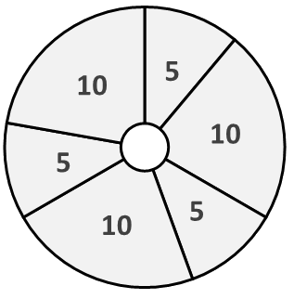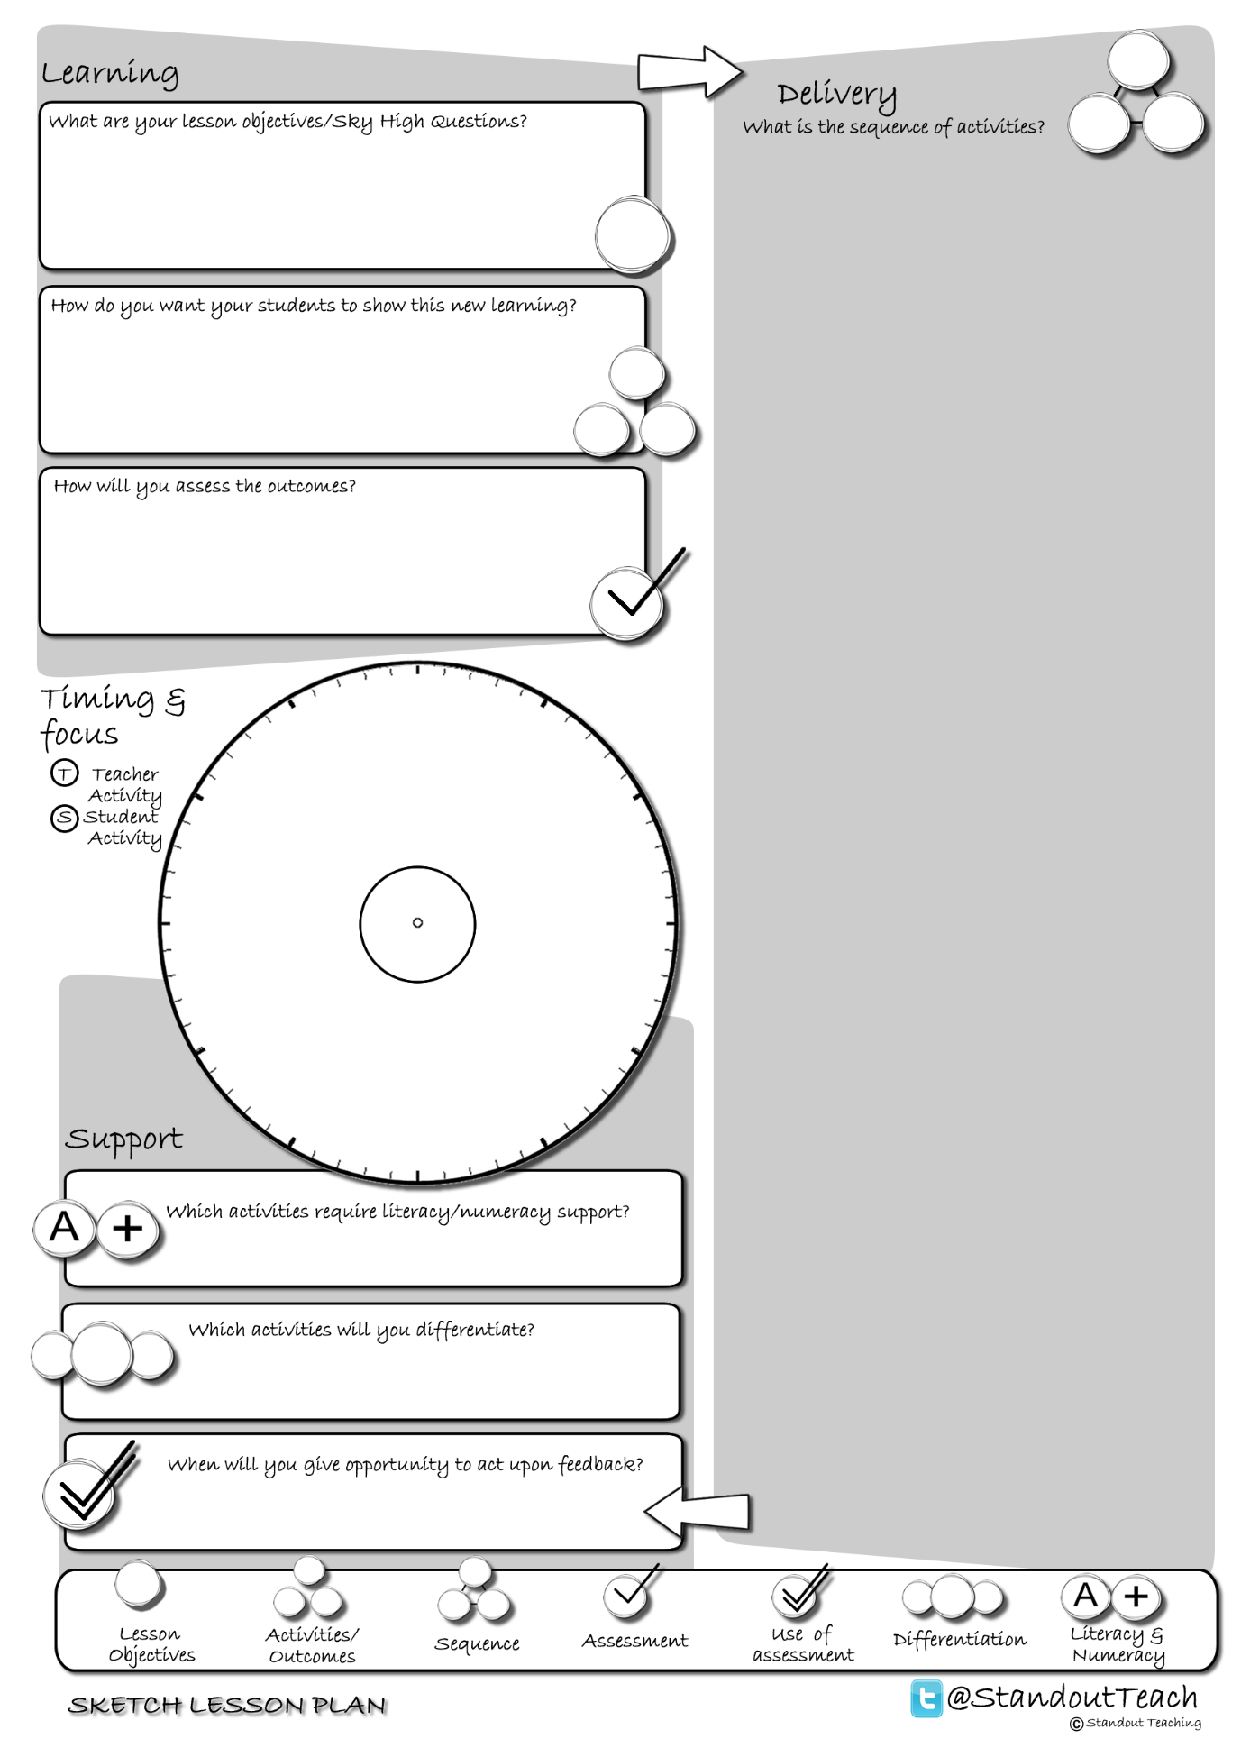

**S**

**S**

**S**

**T**

**S**

**S**

|  |
| --- |
| **Activity 1 : (5 minute) Starter: Individual Activity** |
| [Sky High Questions](http://www.standoutteaching.co.uk/portfolio/sky-high-questions/) : Students read the Sky High Question and underline the keywords. They then reflect on the question and generate a set of additional questions that the Sky High Question poses. |
| **Activity 2 : (10 minute) Individual Pupil Activity** |
| [Query GAP](http://www.standoutteaching.co.uk/portfolio/query-gap/) : Students are to visit a range of resources placed around the room and create a question based upon them. GAP is applied to challenge students through explanation and justification. |
| **Activity 3 : (5 minute) AFL: Questioning - Teacher Led** |
| [Q-Time Bouncing Questions](http://www.standoutteaching.co.uk/portfolio/q-time-bouncing-questions/) : Students are questioned in relation to their learning using the Q-time process- Question, Quiet, Quiz and Query. The later part of the sequence incorporates question bouncing led by the students. |
| **Activity 4 : (10 minute) Paired Activity** |
| [Blooms- Presentations](http://www.standoutteaching.co.uk/portfolio/learning-blooms-presentations/) : Students undertake a Learning Blooms exercise, selecting from one of eight tasks with a focus on presentation outcomes. They will also incorporate GAP differentiation into their task. |
| **Activity 5 : (5 minute) AFL: Paired Assessment** |
| [How well?](http://www.standoutteaching.co.uk/portfolio/how-well/) : Students will be given a set of statements to use to reflect upon their work. They mark if they agree with the statements and then ask a partner to repeat the process in relation to their work. |
| **Activity 6 : (10 minute) Paired Activity** |
| [Lesson Basics- Presentations](http://www.standoutteaching.co.uk/portfolio/lesson-basics-student-presentation/) : Students are to undertake their presentations to the class. The reminder of the class observe the presentation and makes notes to feedback to the presenting group. |
| **Activity 7 : (5 minute) Plenary: Teacher Led** |
| [Sky High Confidence](http://www.standoutteaching.co.uk/portfolio/sky-high-confidence/) : Students read the Sky High Question and underline the keywords. Students then complete a confidence line to show their level of confidence in answering the question. |