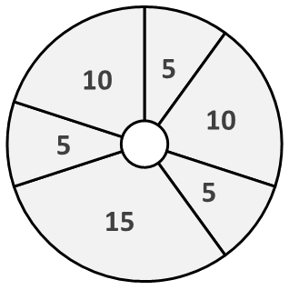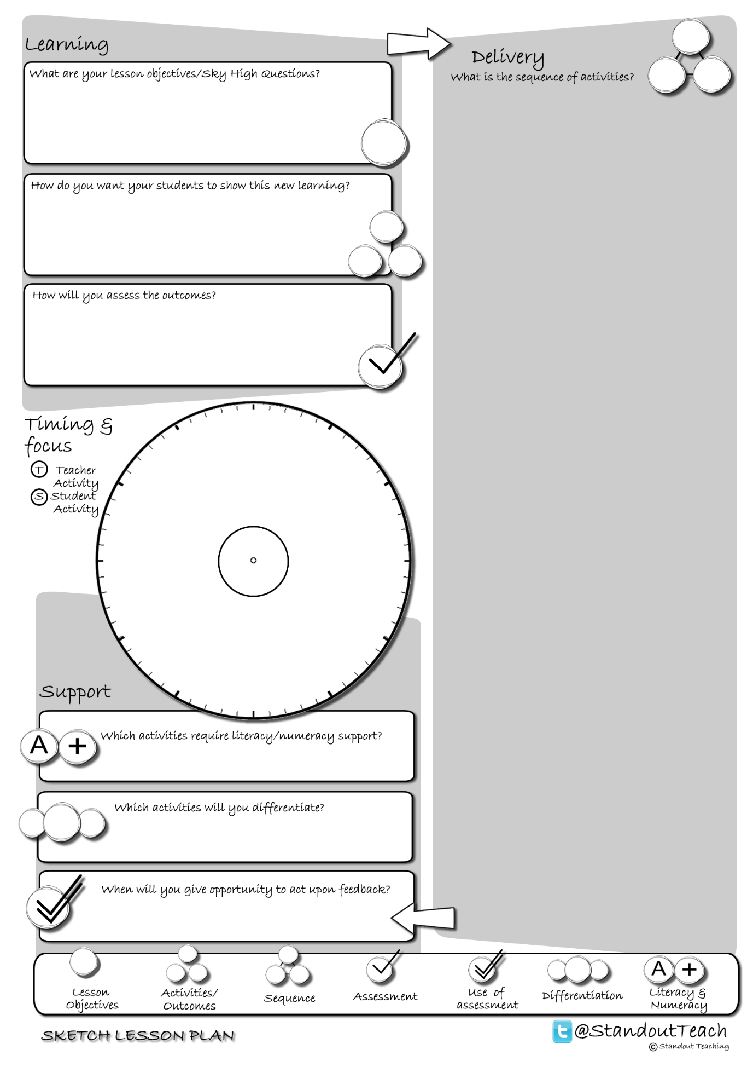

**S**

**S**

**S**

**S**

**S**

**S**

|  |
| --- |
| **Activity 1 : (5 minute) Starter: Paired Activity** |
| [Which one's right?](http://www.standoutteaching.co.uk/portfolio/which-ones-right/) : Students are given 2 statements and in pairs are to read them out; they then decide which is correct. They will then be required to feedback to the class and justify their answers. |
| **Activity 2 : (10 minute) Individual Pupil Activity** |
| [I'm the Teacher GAP](http://www.standoutteaching.co.uk/portfolio/im-the-teacher-gap/) : Around the room is a range of tasks for students to visit and undertake. Each task has GAP applied to differentiate and challenge the students. Students will have 5 minutes to complete each task. |
| **Activity 3 : (5 minute) AFL: Self Assessment** |
| [BIG Circles Pt1](http://www.standoutteaching.co.uk/portfolio/big-circles-pt1/) : Using the Circles worksheet students will reflect upon a piece of work that they have completed and state 3 areas to develop further (Part 1). This is a 3 stage process- baseline, improving and checking. |
| **Activity 4 : (15 minute) Individual Pupil Activity** |
| [Connect- PEE](http://www.standoutteaching.co.uk/portfolio/connect-pee/) : Students are to write an argument using the PEE formula to construct it. They must make their point, provide evidence to support this then explore the point using the evidence to reinforce. |
| **Activity 5 : (5 minute) AFL: Self Assessment** |
| [BIG Circles Pt3](http://www.standoutteaching.co.uk/portfolio/big-circles-pt3/) : This is part 3, the final stage of this process. Students have already identified areas to improve and then applied the findings to their work. The final stage is to check against the targets they have set and ensure they have completed them all. |
| **Activity 6 : (10 minute) Plenary: Paired Activity** |
| [Sky High Question Answer](http://www.standoutteaching.co.uk/portfolio/sky-high-question-answer/) : Students are to reflect back upon their learning from the lesson and answer the Sky High Question. They will need to use keywords, explain and justify their answers. |