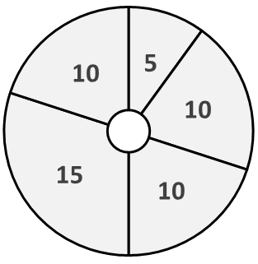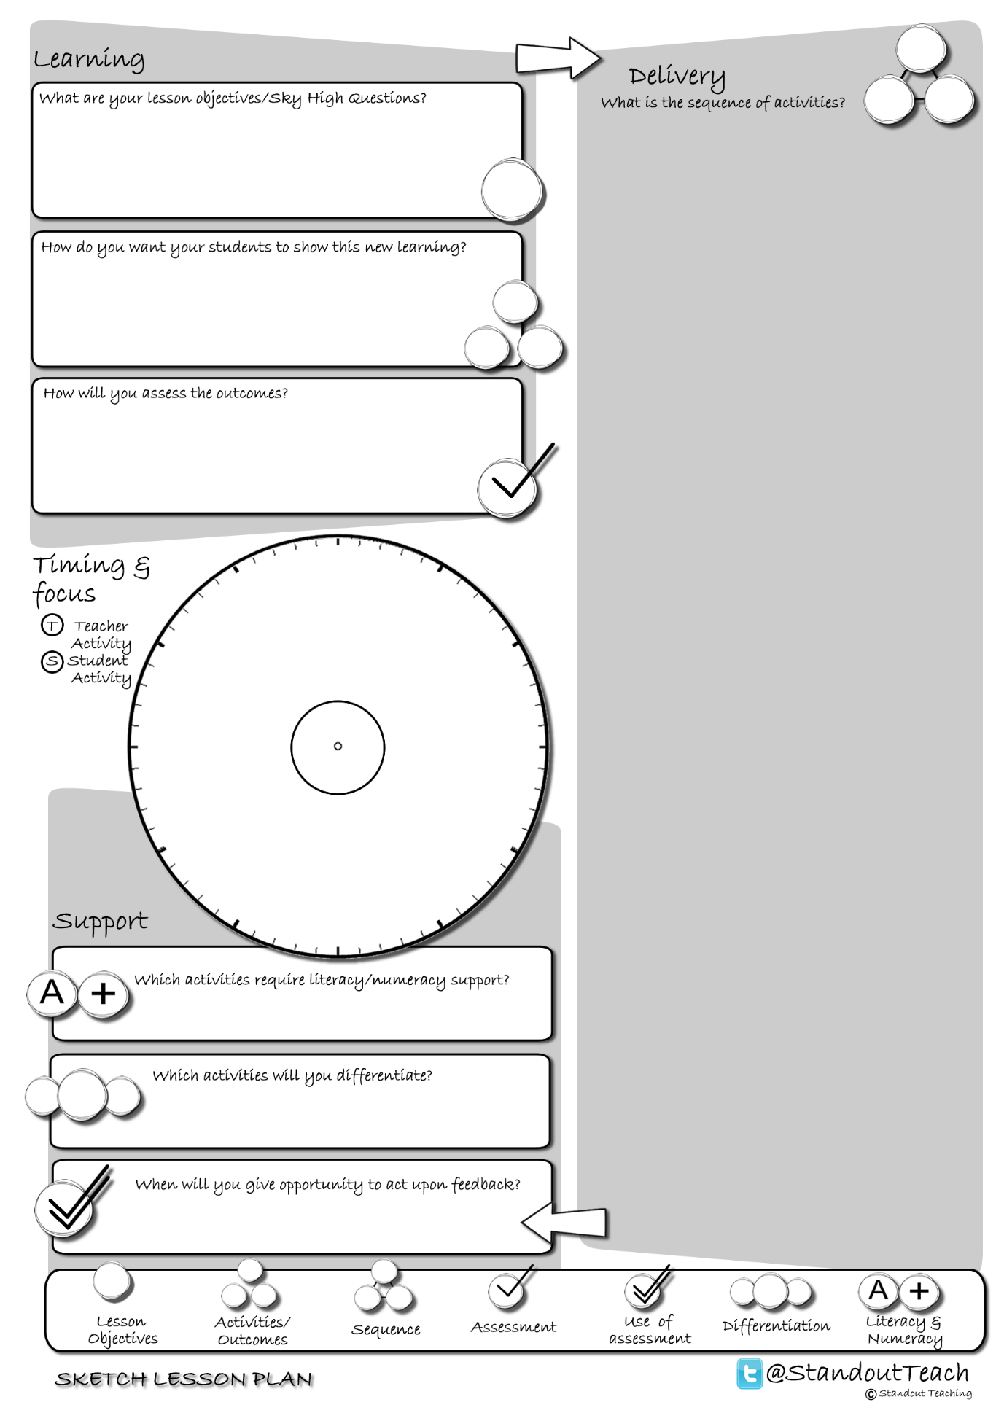

**T**

**S**

**S**

**S**

**S**

|  |
| --- |
| **Activity 1 : (5 minute) Starter: Paired Activity** |
| [Sky High Mind Map (GAP)](http://www.standoutteaching.co.uk/portfolio/sky-high-mind-map-gap/) : Students read the Sky High Question and underline the keywords. Students create a mind map related to the Sky High Question then expand on each point they have made (GAP task). |
| **Activity 2 : (10 minute) Individual Pupil Activity** |
| [Connect- SUB](http://www.standoutteaching.co.uk/portfolio/connect-sub/) : Students are given a piece of text, to which they will then apply SUB. Firstly they scan the text, then underline the key points before finally drawing a box around the keywords. |
| **Activity 3 : (10 minute) Individual Pupil Activity** |
| [Lesson Basics- Mind Mapping](http://www.standoutteaching.co.uk/portfolio/lesson-basics-mind-mapping/) : Students undertake a mind mapping exercise related to the lesson. They will be required to self-assess against the requirements of the task, check keywords and complete the exercise within a set time. |
| **Activity 4 : (15 minute) Individual Pupil Activity** |
| [Learning Blooms- Writing](http://www.standoutteaching.co.uk/portfolio/learning-blooms-writing/) : Students undertake a Learning Blooms exercise, selecting from one of eight tasks with a focus on written outcomes. They will also incorporate GAP differentiation into their task. |
| **Activity 5 : (10 minute) Plenary: Teacher Led** |
| [Sky High Plenary Questions](http://www.standoutteaching.co.uk/portfolio/sky-high-plenary-questions/) : Students are to reflect back upon their learning from the lesson and answer the Sky High Question. Once complete they will then create 3 Sky High Questions of their own. |