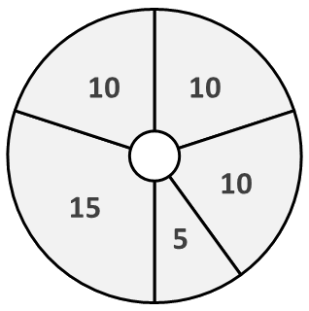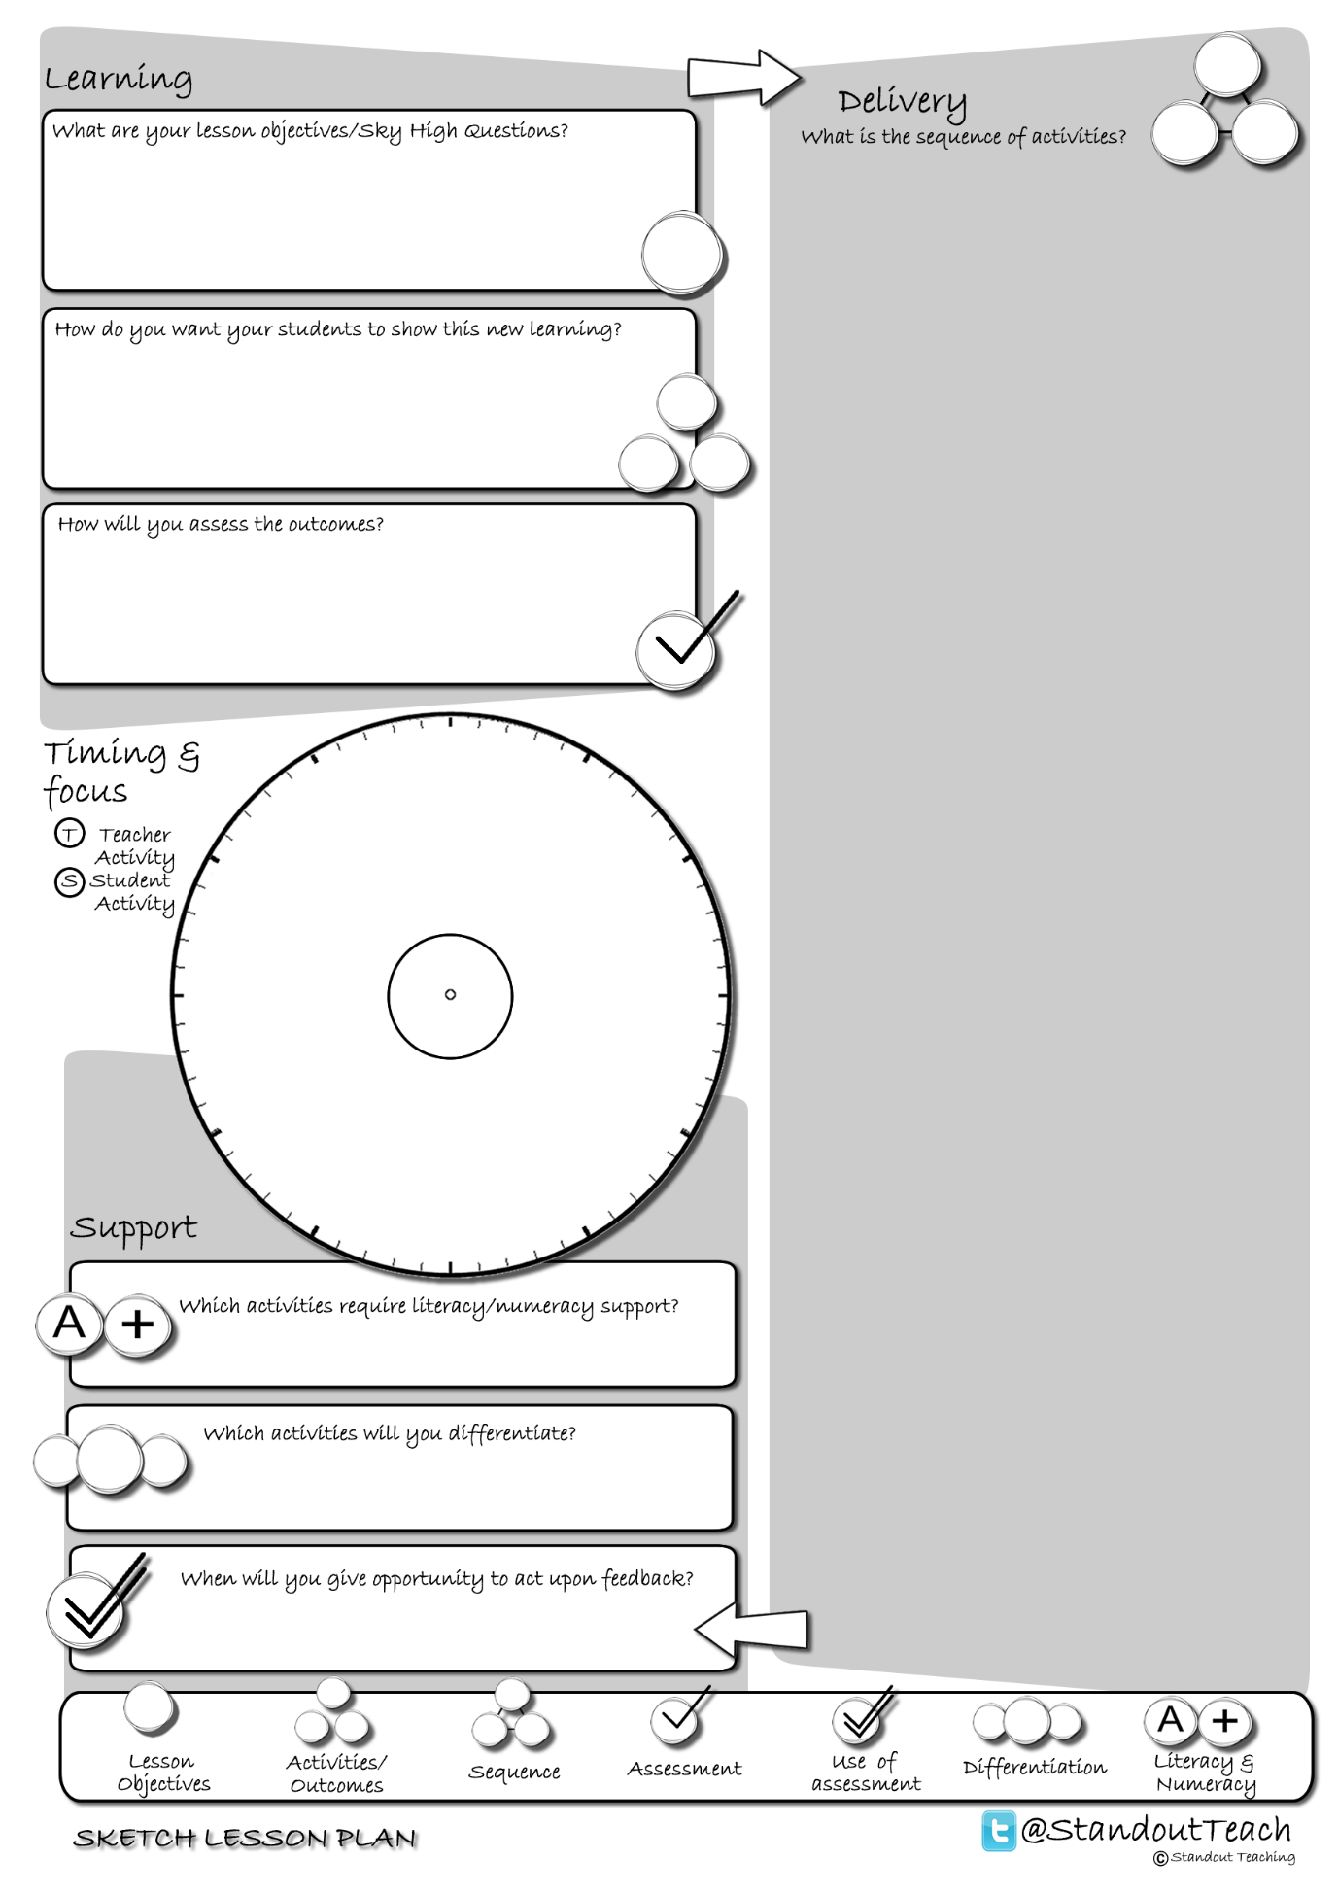

**S**

**S**

**T**

**S**

**S**

|  |
| --- |
| **Activity 1 : (10 minute) Starter: Group Activity** |
| [Photo Mystery](http://www.standoutteaching.co.uk/portfolio/photo-mystery/) : Working in groups, students are given a photo and a set of questions to answer related to it. They are to answer the questions then feedback to the class their findings. |
| **Activity 2 : (10 minute) Individual Pupil Activity** |
| [Another Way GAP](http://www.standoutteaching.co.uk/portfolio/another-way-gap/) : Students are issued with a piece of text which is differentiated and signposted with GAP. They are then given the option to convert it into a mind map, storyboard, bullet point list or flow chart. |
| **Activity 3 : (5 minute) AFL: Questioning - Teacher Led** |
| [Q-Time Questioning](http://www.standoutteaching.co.uk/portfolio/4114/) : Students are questioned in relation to their learning using the Q-time process- Question, Quiet, Quiz and Query. This is used to inform the structure of future learning within the lesson. |
| **Activity 4 : (15 minute) Individual Pupil Activity** |
| [Connect- PQE](http://www.standoutteaching.co.uk/portfolio/connect-pqe/) : Students are to construct an argument referencing a piece of text. To do this they are to use the PQE formula- Point, Quote and Explore. They can repeat this formula as many times as necessary. |
| **Activity 5 : (10 minute) Plenary: Group Activity** |
| [Question the task](http://www.standoutteaching.co.uk/portfolio/question-the-task/) : In groups, students are to write 4 questions related to the lesson. Then, as a competition, they pose their questions to the rest of the class to answer. |